**AI + Azure DevOps Workshop**

**Introduction**

This lab uses Azure DevOps and Azure Machine Learning and is heavily based on the work and guidance Praneet Singh Solanki has provided and published to the git repository here: <https://github.com/Microsoft/MLOpsPython>.

**Objectives**

This lab covers the following topics.

1. Setup and configure your MLOps environment to automatically execute Azure Machine Learning pipelines from Azure DevOps
2. Create three machine learning pipelines: one each for building, re-training, and deploying your model.

**Prerequisites**

The following are required to complete this hands-on lab:

* An active Microsoft Azure subscription. If you don't have one, [sign up for a free trial](http://aka.ms/WATK-FreeTrial).
* Contributor level access (or higher) to the Azure subscription
* Access to an Azure DevOps account
* A service principal. A service principal and credentials will be used for authentication within the Azure machine learning pipelines. A service principal is created outside of the subscription in Azure Active Directory. This means in order to use it for AML pipelines, the service principal needs to be assigned to a contributor role within the Azure subscription.
* Git must be installed on your machine.

If you need step-by-step guidance on how to affect these pre-requisites, pleases see the *MandatoryLabPreReq* document in this repository.

**Exercises**

This hands-on lab includes the following exercises:

* Exercise 1: Download and unzip the workshop repo to your local machine
* Exercise 2: Create a new project in your Azure DevOps account
* Exercise 3: Create a service connection for Azure DevOps
* Exercise 4: Store secrets in a variable group
* Exercise 5: Setup a repository in Azure DevOps
* Exercise 6: Setup the Build Pipeline
* Exercise 7: Setup the Re-training Pipeline
* Exercise 8: Setup the Deployment Pipeline
* Exercise 9 (optional): View resources from Azure portal

Estimated time to complete this lab: **90-120 mins.**

# Exercise 1: Download and unzip the workshop repo to your local machine

In this exercise, you will download the contents of the workshop GitHub repo and unzip it to your local machine.

Caution: do not clone the GitHub repo, download the zip as shown below.

Content for this workshop is in a GitHub repo here: <https://github.com/gmarchet/dnnworkshop4/> and includes the slides, documents, code, and scripts.

1. Navigate to the git repository and click on **Clone or download**, then click on **Download ZIP** and save the zip to your local machine:

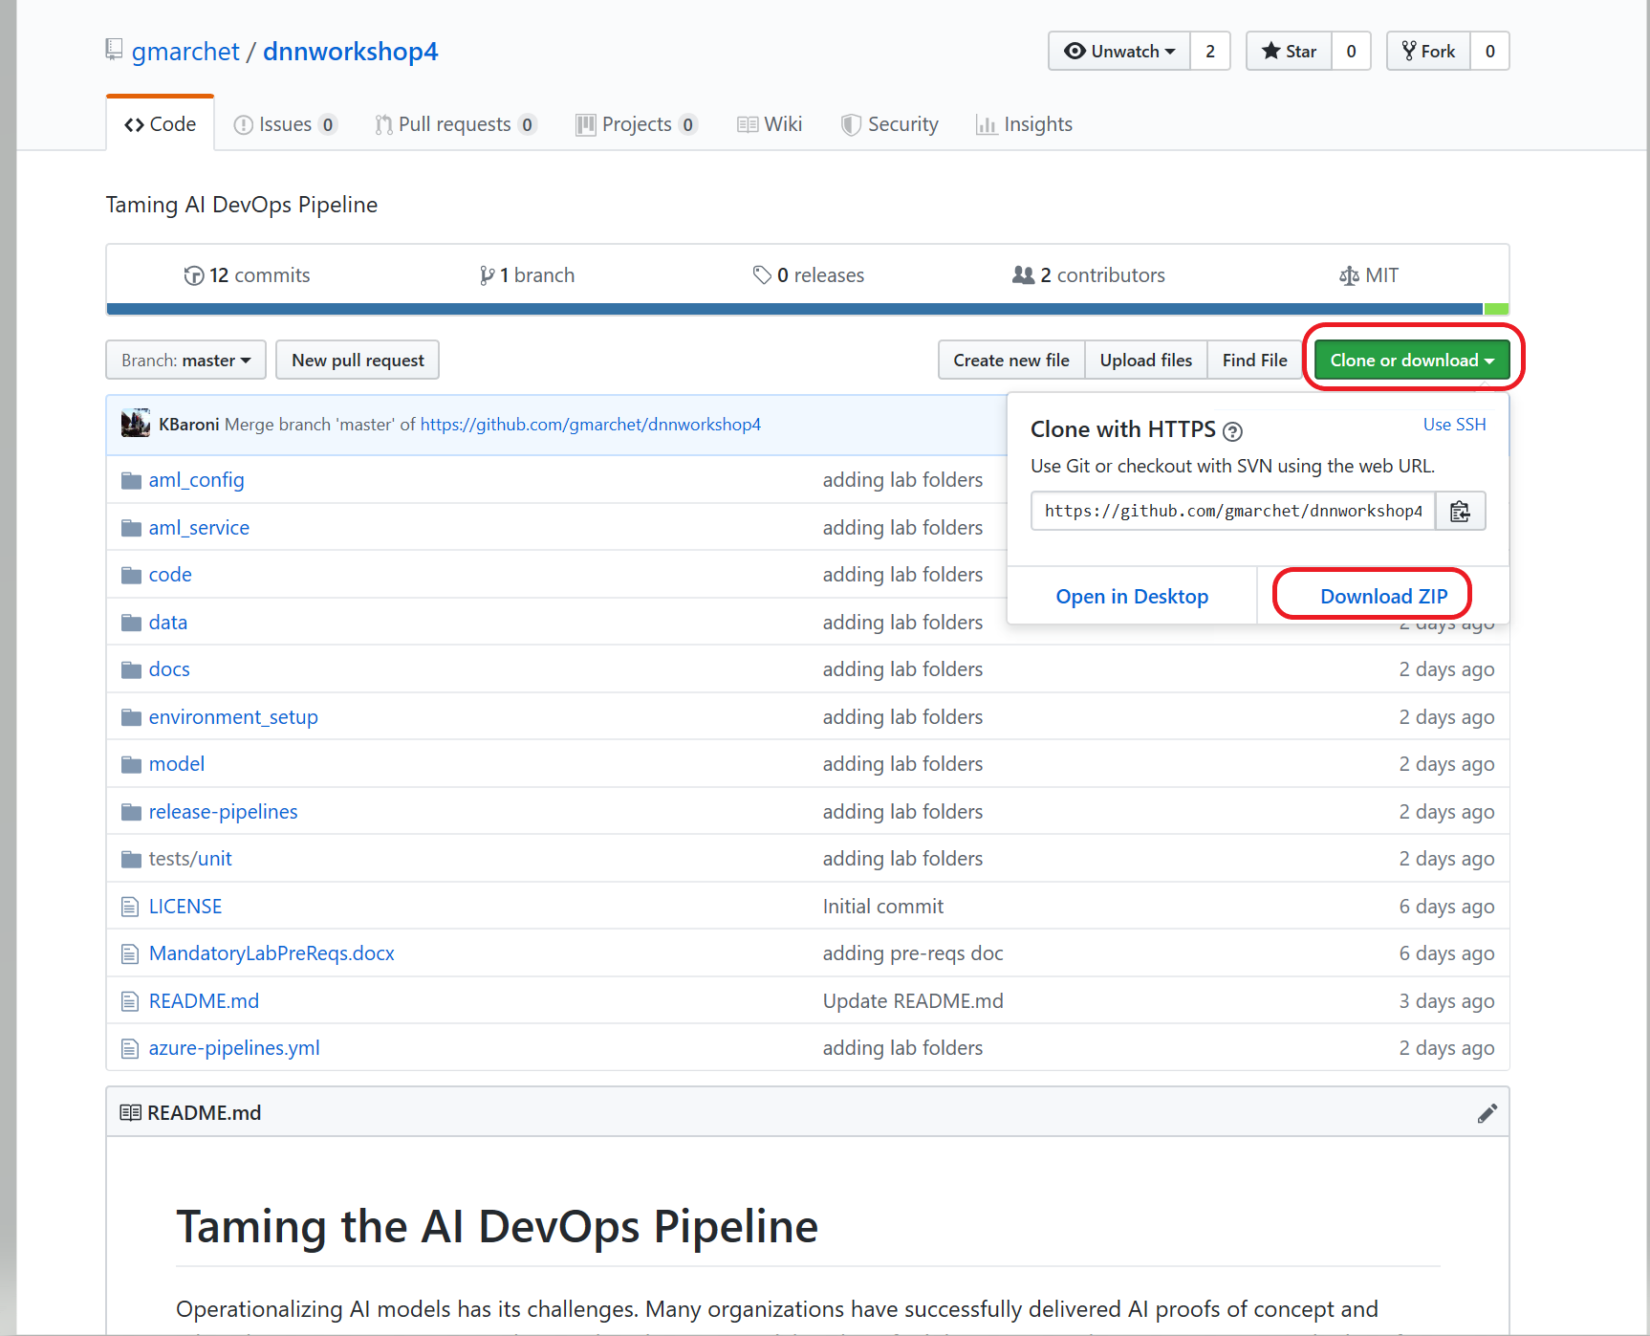

*GitHub repo for Workshop*

1. Unzip the file on your local machine
2. Bring up a command line window and change directory into the workshop folder **dnnworkshop4-master** that contains the code.
3. On the command line, execute a series of git commands to initialize the directory as a version control project and prepare it to use with Azure DevOps:

**git init**  <to initialize the directory for version control>

**git status** *<to check the current status of the directory>*

**git add .** <will add all the files into the staging area>

**git commit -m “Initial Build”** <creates a commit>

1. On Windows, the directory will now resemble the following and is ready to be pushed to Azure DevOps:

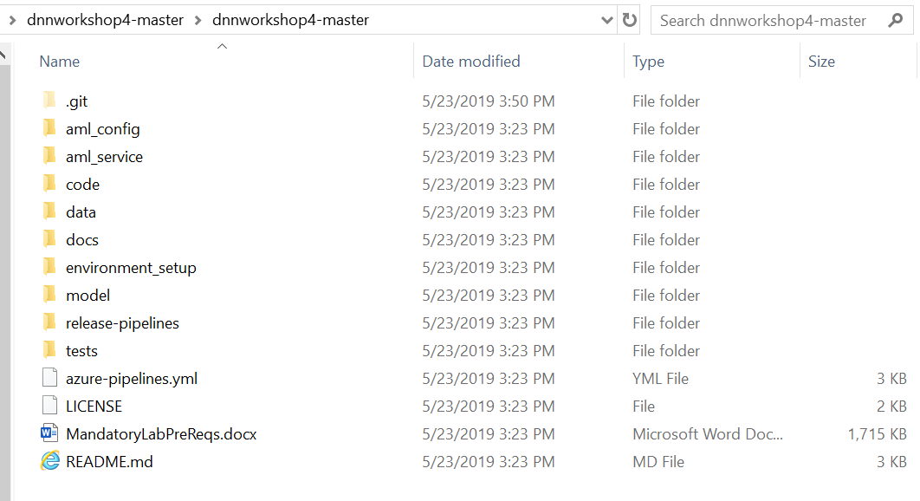

# Exercise 2: Create a new project in your Azure DevOps account

In this exercise, you will setup an Azure DevOps project as the 1st step in setting up the three pipelines.

1. Navigate to <http://devops.azure.com>
2. If there are multiple organizations, select the one you will be using to host this project. Alternatively, you can create a new organization and create your project in the new organization..
3. Create a project and name it

Project name: <Your initials>_DevOps.

The project is available when a welcome screen appears similar to the below image.

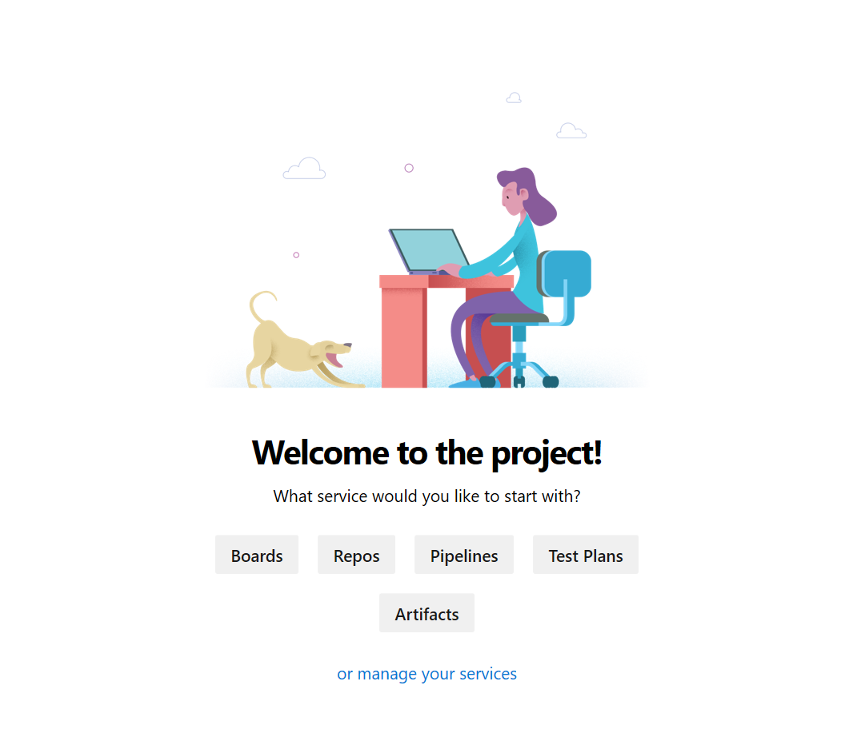

# Exercise 3: Create a service connection for Azure DevOps

To deploy the pipelines to Azure, you need to create an Azure Resource Manager service connection in Azure DevOps. To create the service connection, you need the information about the service principal required in this lab’s pre-requisites. To complete this exercise, you need the following parameters:

* Azure subscription ID
* Azure subscription name
* Service principal client ID
* Service principal password/key
* Tenant ID

To create a service connection:

* 1. Navigate to Project Settings by clicking on ‘manage your services’

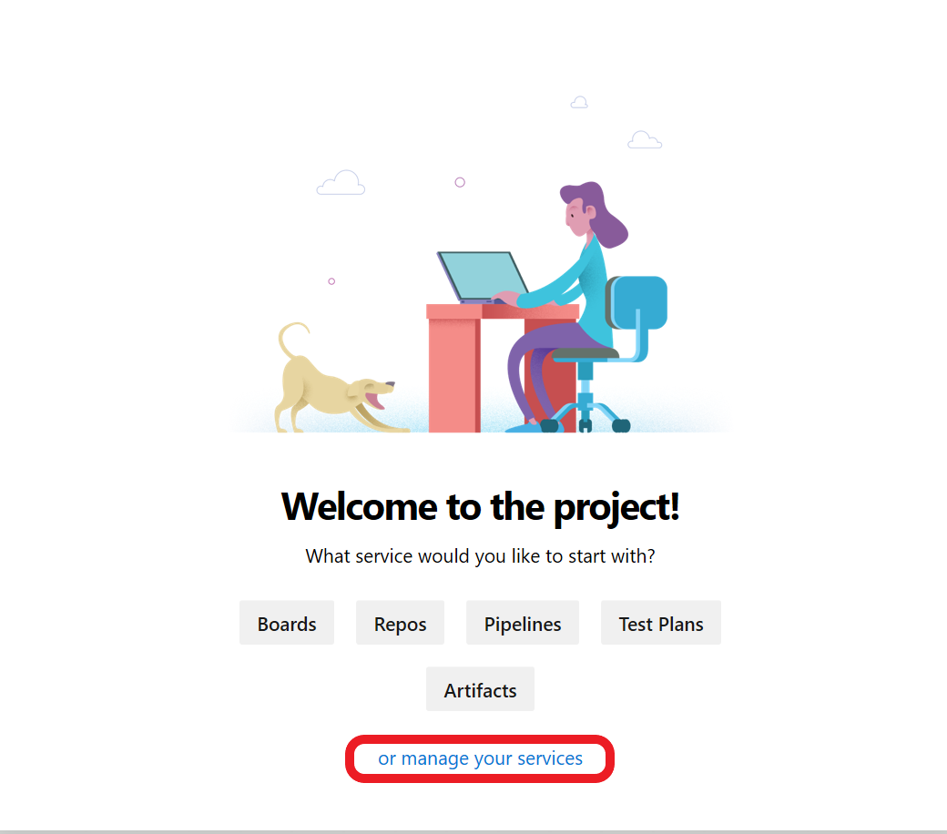

* 1. Under Project Settings, select **Service Connections** -> **New service connection** and select **Azure Resource Manager** from the drop down.

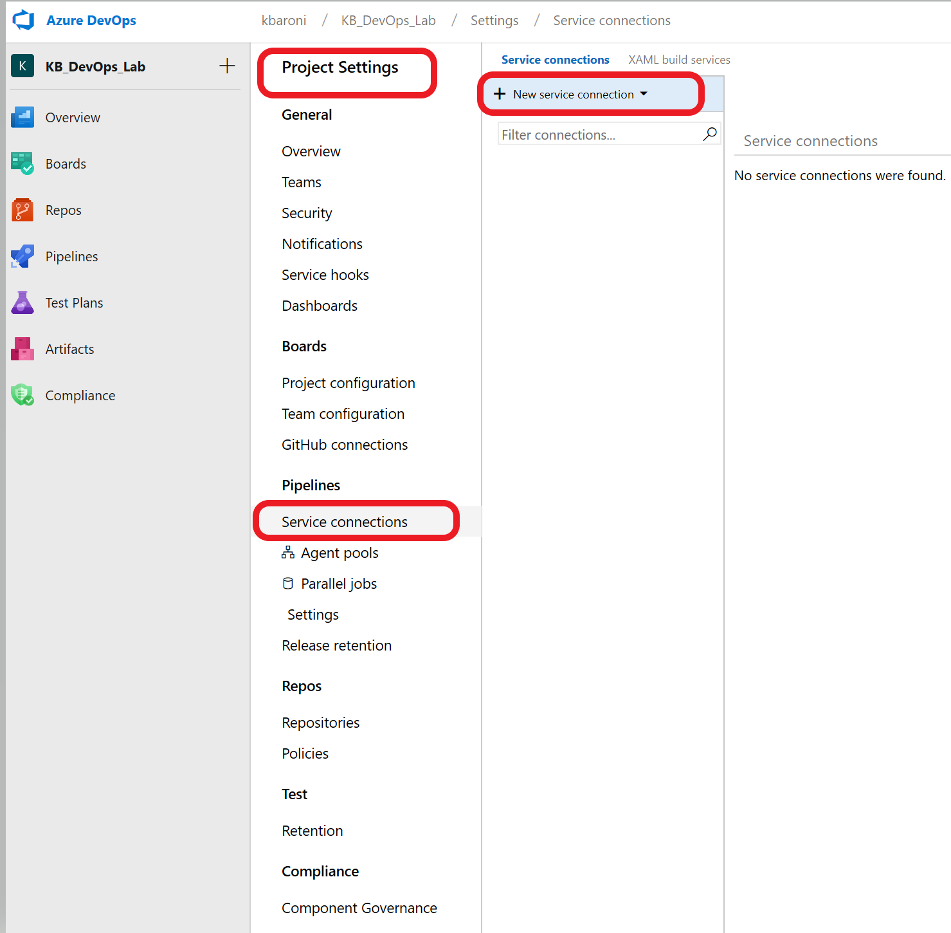

* 1. When the connection screen comes up, enter in the following parameters.

Connection name: DevOpsLab

Scope level: Subscription

Subscription: Select the Azure subscription you will use for the lab

Resource Group: (leave it blank)

And then click on ‘**use the full version of the service connection dialogue**’ as shown below.

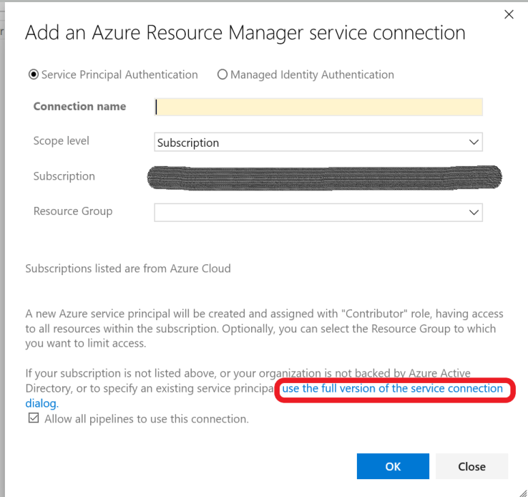

* 1. When the screen expands, add in the following parameters:

Service principal client ID: <the service principal ID>

Service principal key: <the service principal password>

Tenant ID: this may auto-populate with your <your tenant ID>

* 1. Click on **Verify connection** to confirm a valid service connection. Your screen should look similar to the image below.

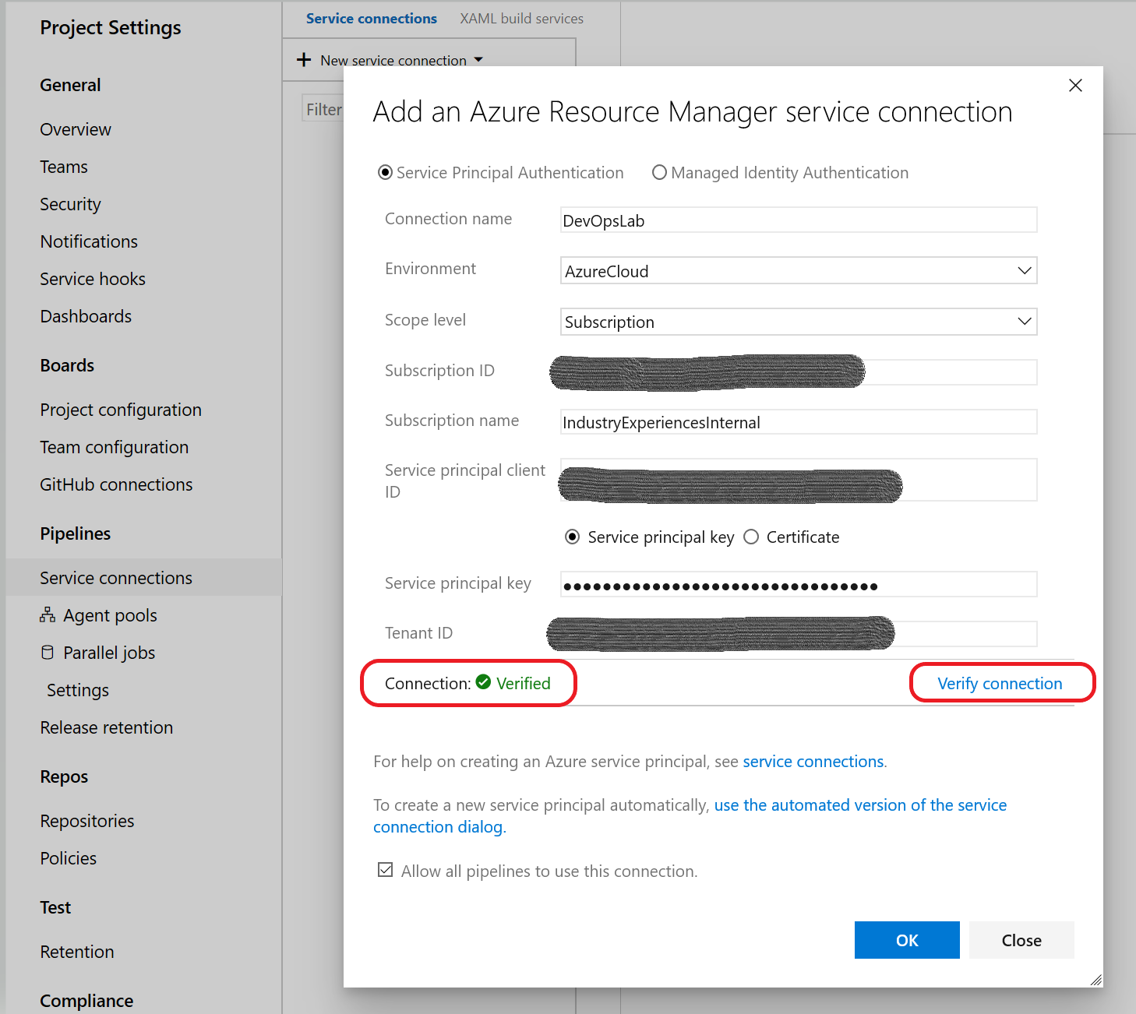

*Service connection configuration is checked and verified*

* 1. When the connection is verified, click on **OK**.

If you encounter an error after entering valid values for the parameters above, it is likely the service principal has not been granted contributor level role at the subscription level. The subscription admin must do before you can proceed with the lab.

# Exercise 4: Store secrets in a variable group

A variable group is a logical container that stores variables and their properties (like key/value pairs). They can contain API keys, database connection strings, or API endpoints. For this lab, we will create a variable group to store the credentials and secrets needed to access the Azure subscription and provision resources. A variable group can be shared between pipelines. To complete this exercise, you need the following variables and values:

Azure subscription ID (subscriptionid)

Service principal client ID (spidentity)

Service principal password/key (spsecret)

Tenant ID (sptenant)

To create a variable group:

1. In your Azure DevOps project, navigate to the **Pipelines** icon on the left panel and select **Library** and click on **+Variable group** as shown below.

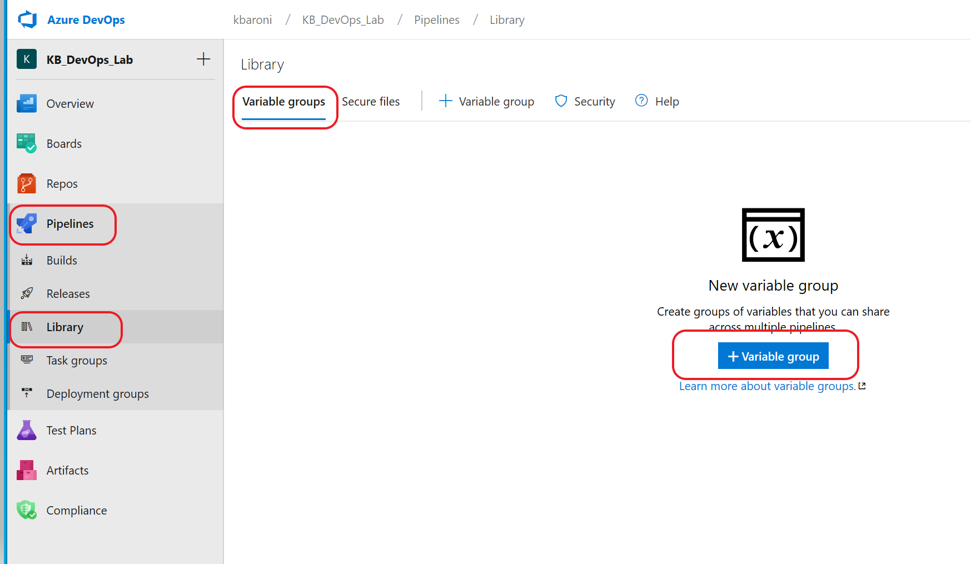

1. Name the variable group: **AzureKeyVaultSecrets** (this is hard coded in the build file)
2. Add each of the following variables to the variable group with their corresponding value:

spidentity (the service principal id)

spsecret (the service principal key/password)

sptenant (the tenant ID)

subscriptionid (the azure subscription id)

1. **BE SURE** to click **SAVE** before navigating away from the Variable group page.

# Exercise 5: Setup a repository in Azure DevOps

The DevOps project reads from a git repository. In this exercise we will push the repo we created earlier to the repo in this Azure DevOps project.

1. Navigate to the Repos icon on the left pane.
2. Copy the git commands under the section **push an existing repository from command line**.
3. Navigate to the directory where you prepared the workshop repo and issue the 2 commands you copied from the DevOps Repos page as shown in the image below.

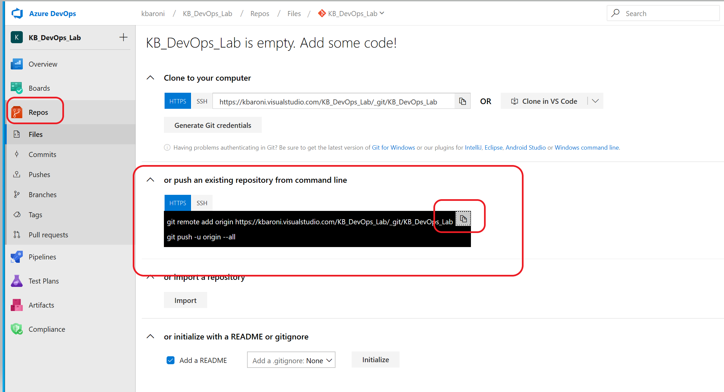

4. Navigate back to your DevOps project and Select Repos from the left pane to confirm the code and scripts have been uploaded as shown below.

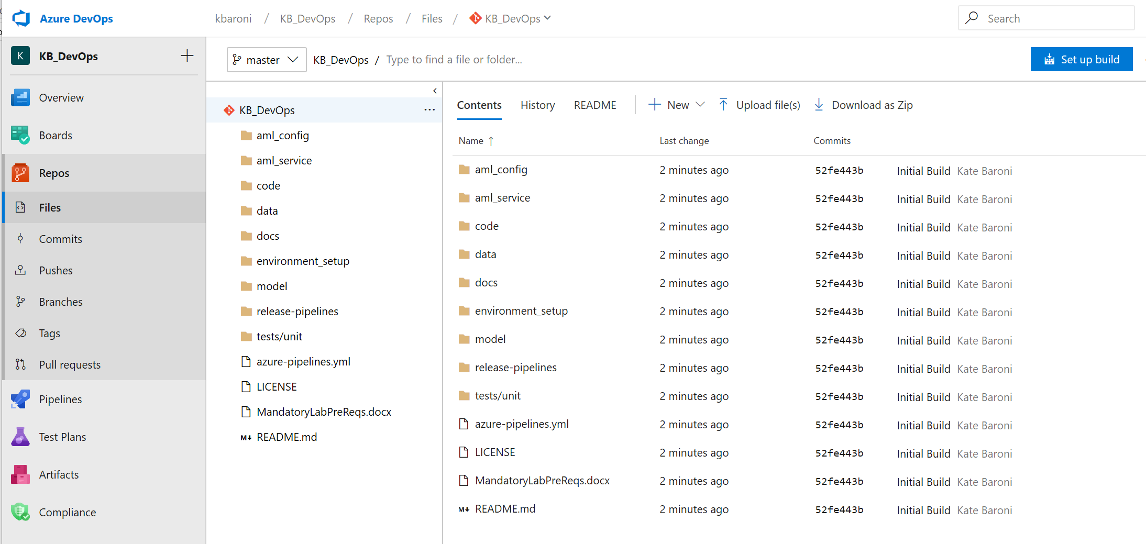

With this exercise completed, you are ready to setup the build, re-training, and release pipelines.

# Exercise 6: Setup the Build Pipeline

A build pipeline defines the steps to take during a build process. Build pipelines are usually triggered based on a code commit but may be manually initiated. In this exercise, you will setup and manually execute a build pipeline that will provision the infrastructure in Azure, execute the build, and run a unit test.

1. Select **Pipelines** from the left pane and click on **New pipeline** and you will see a screen similar to the one below. Select **Azure Repos Git** which will display the repo you associated with this project:

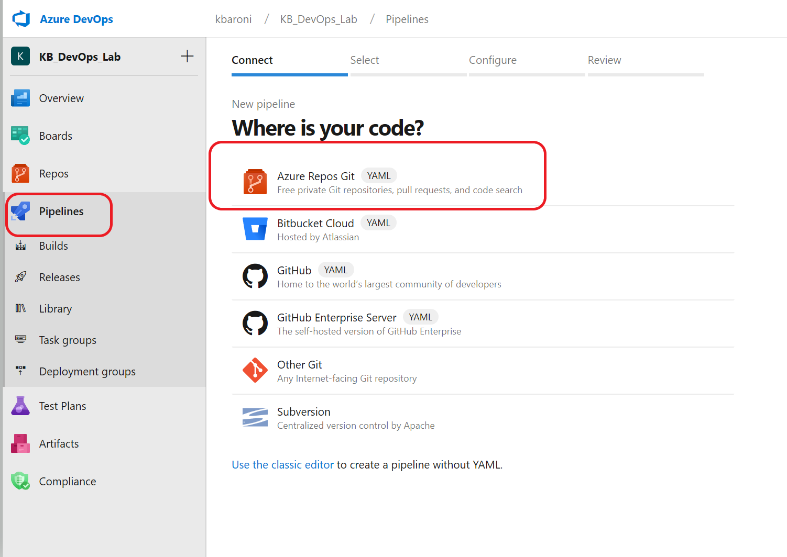

1. Select the repo you pushed to this project in an earlier step:

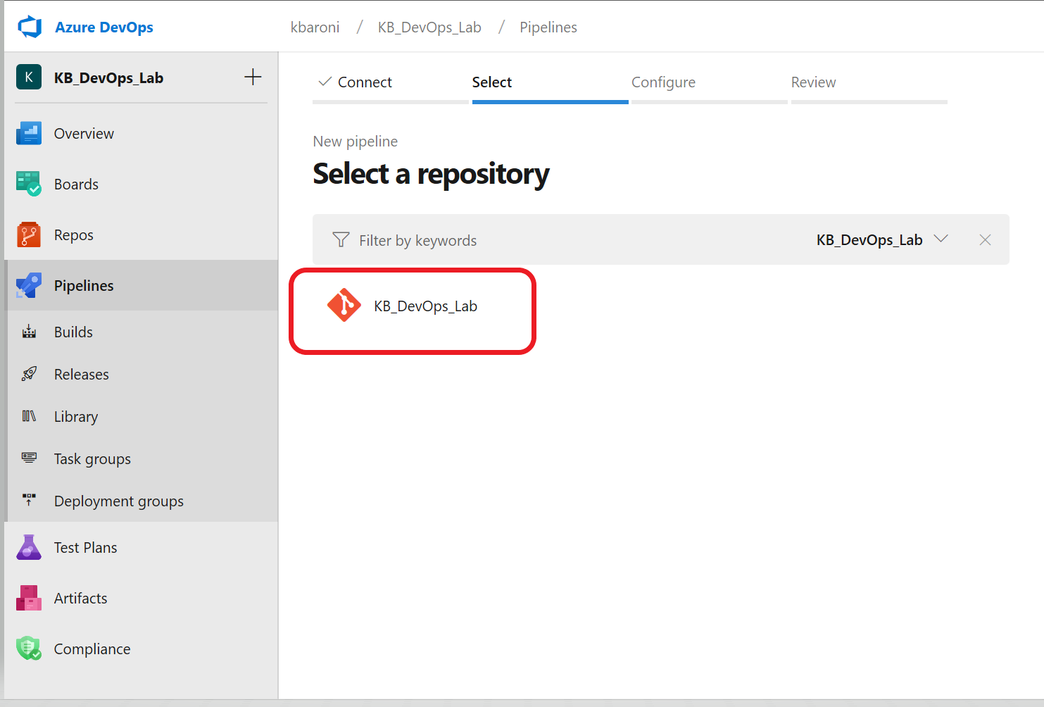

1. A special YAML file (*azure-pipelines.yml*) defines the DevOps Pipeline steps and because it already exists in the repository, it will be automatically loaded. Open the YAML file and notice the first section references the variables stored in the variable group as shown below. Scroll through to see the scripts and tasks that will be executed.

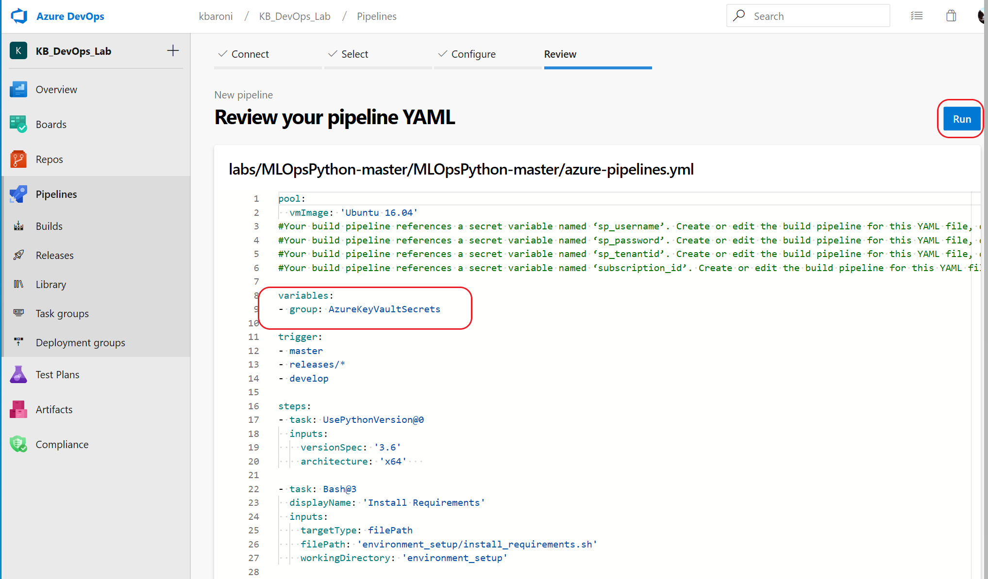

1. When you are ready, click **Run**to manually execute the pipeline.
2. While the build is executing notice that it does a quality check on the data, creates a compute cluster, creates and tests an Azure Machine Learning Pipeline, and reports the build status as the build pipeline executes.

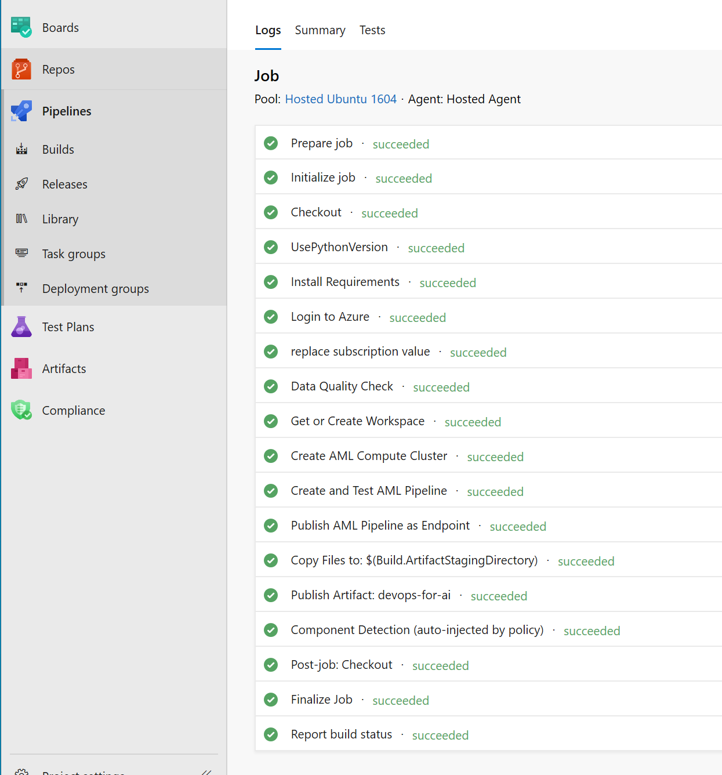

1. The build takes 5-10 minutes to complete and you will get an email confirming the build success in your inbox, similar to the image below.

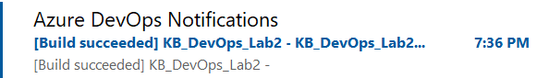

The next step is to create a re-training pipeline that is triggered every time a successful build executes.

# Exercise 7: Setup the Re-training Pipeline

The re-training pipeline is a release pipeline; it takes an existing build artifact and deploys it to a target system. Rather than starting from scratch you will import a pre-defined release-pipeline.

In order to import a release pipeline, you need to create a pipeline with an empty job.

1. Navigate to the ‘Releases’ icon on the left panel and click ‘New pipeline’.

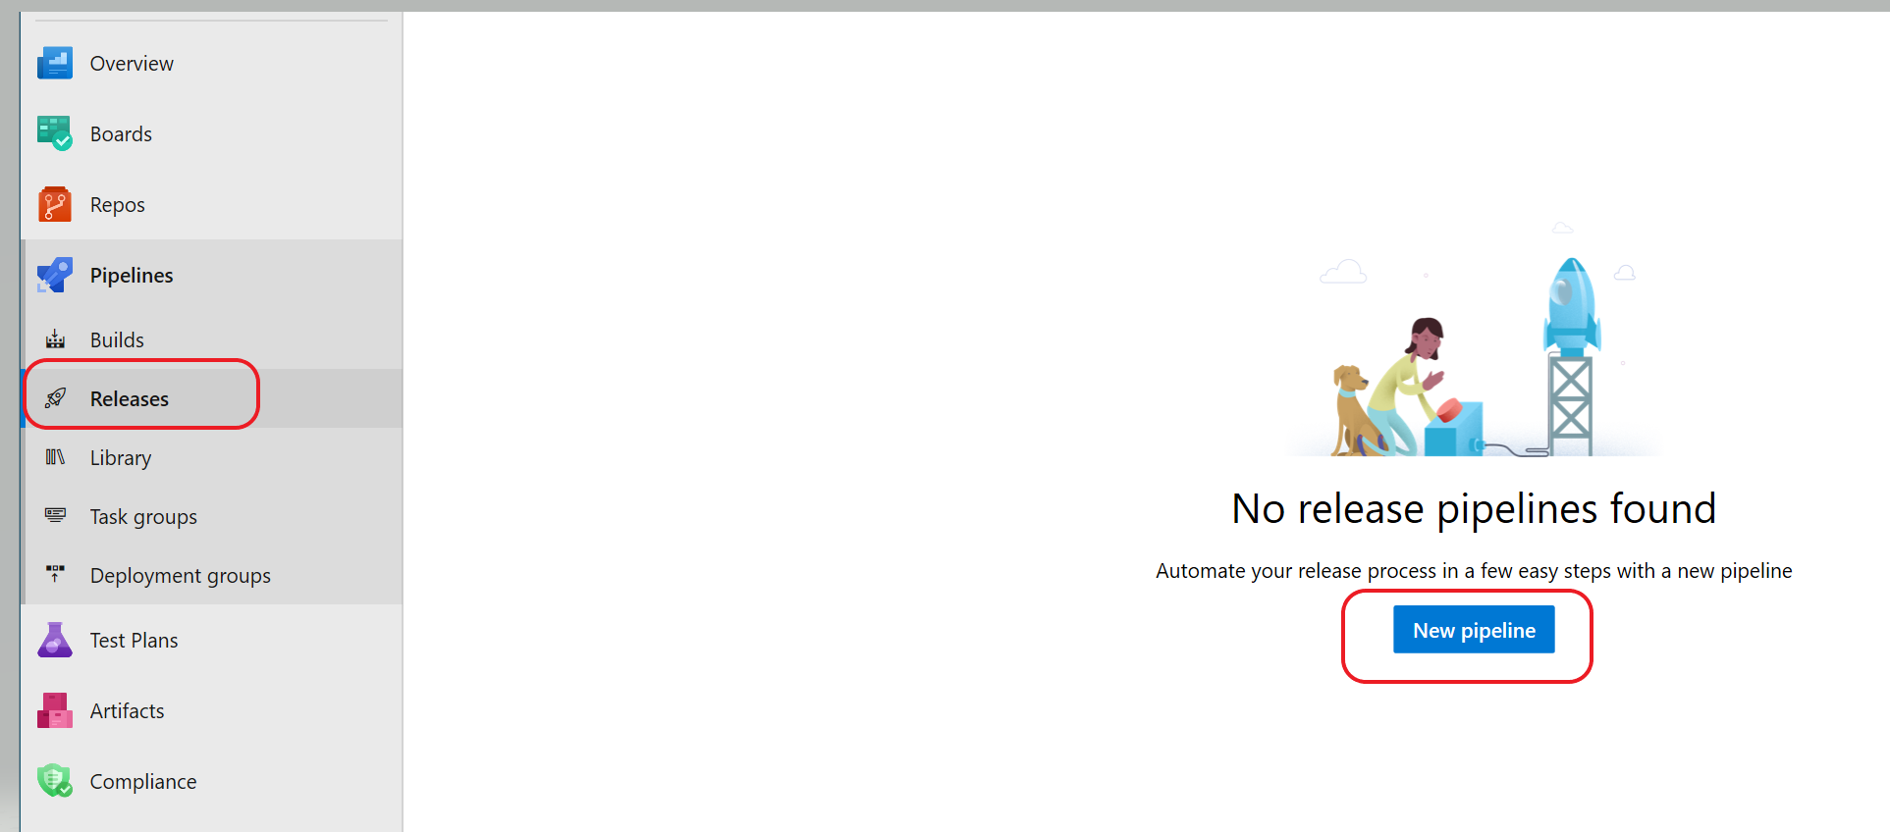

1. Select **Empty Job** instead of selecting a template as shown below.

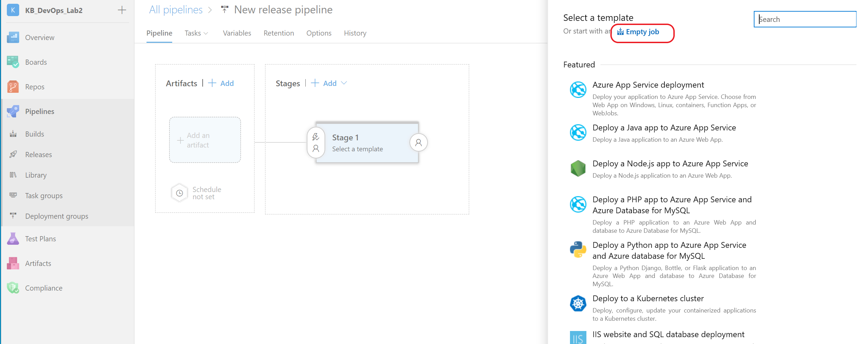

1. On the next screen, select **Save** to save the empty job and then **OK**.

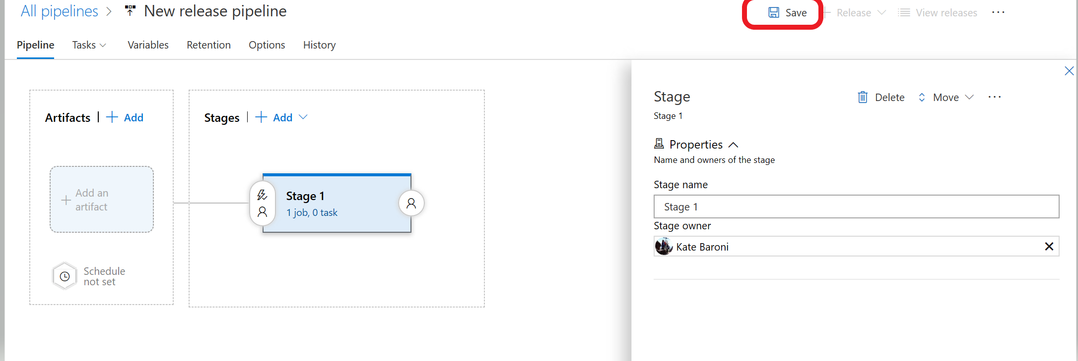

You have ceated an empty job. With the empty job, you can now import the pipeline.

1. Select the **Releases** icon from the left pane and this time there will be an option to select **+New** with a drop down. Select **import release pipeline**

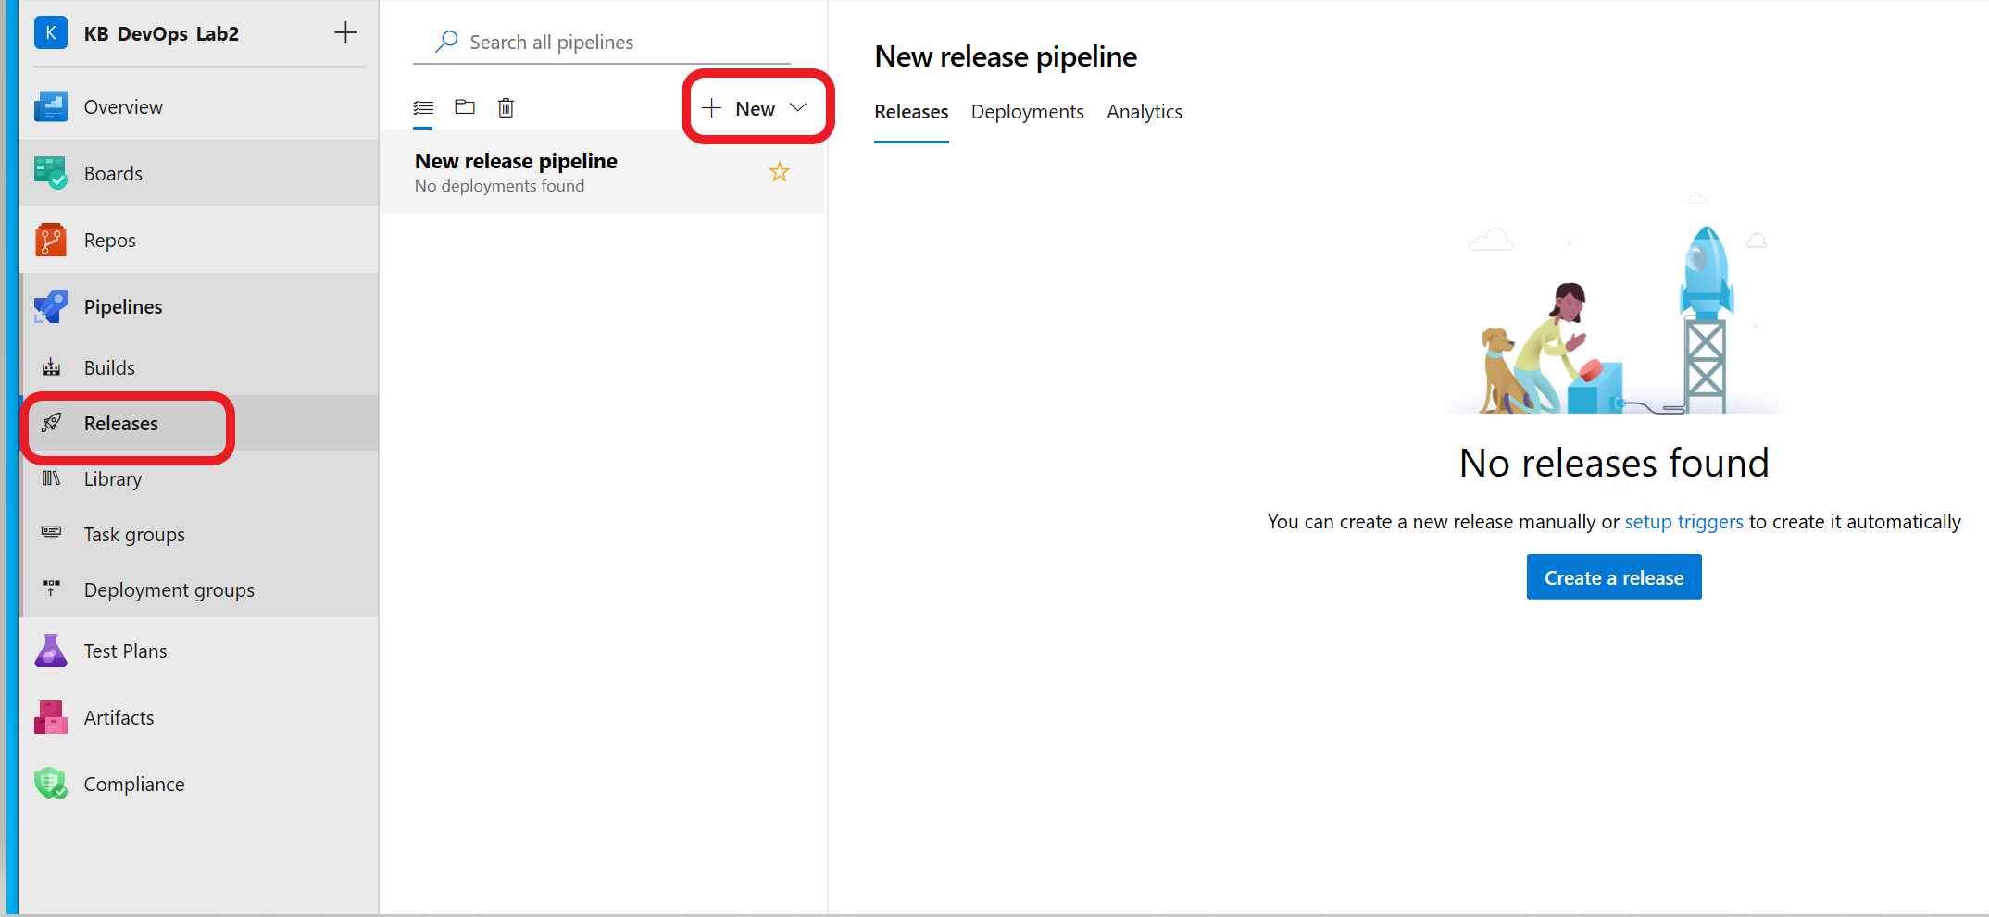

1. On the next screen, browse to the **release-pipelines folder** and select the **retrainingtrigger.json** file. Click **OK** to import. You will see a screen similar to the one below.
2. The next step is to configure the Agent job defined under **Stages.** Click next to the red error sign to display the tasks defined for the agent job.

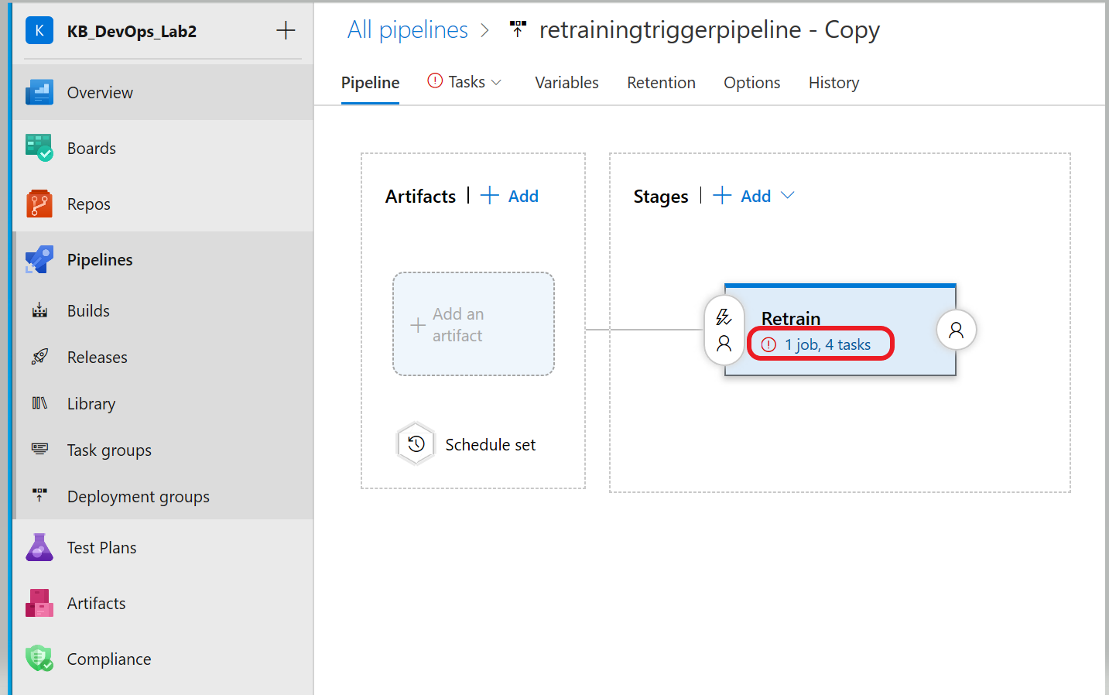

To build or deploy in Azure DevOps you need at least one agent and you have the option to run the jobs with a hosted agent. Each time you run the pipeline you get a fresh virtual machine. For this step, you are going to specify the pool where your agent job will run.

1. Click on **Agent job** to bring up the settings and set the **agent pool** by selecting **Hosted Ubuntu 1604** from the drop-down**.** Click **Save** and **OK**.

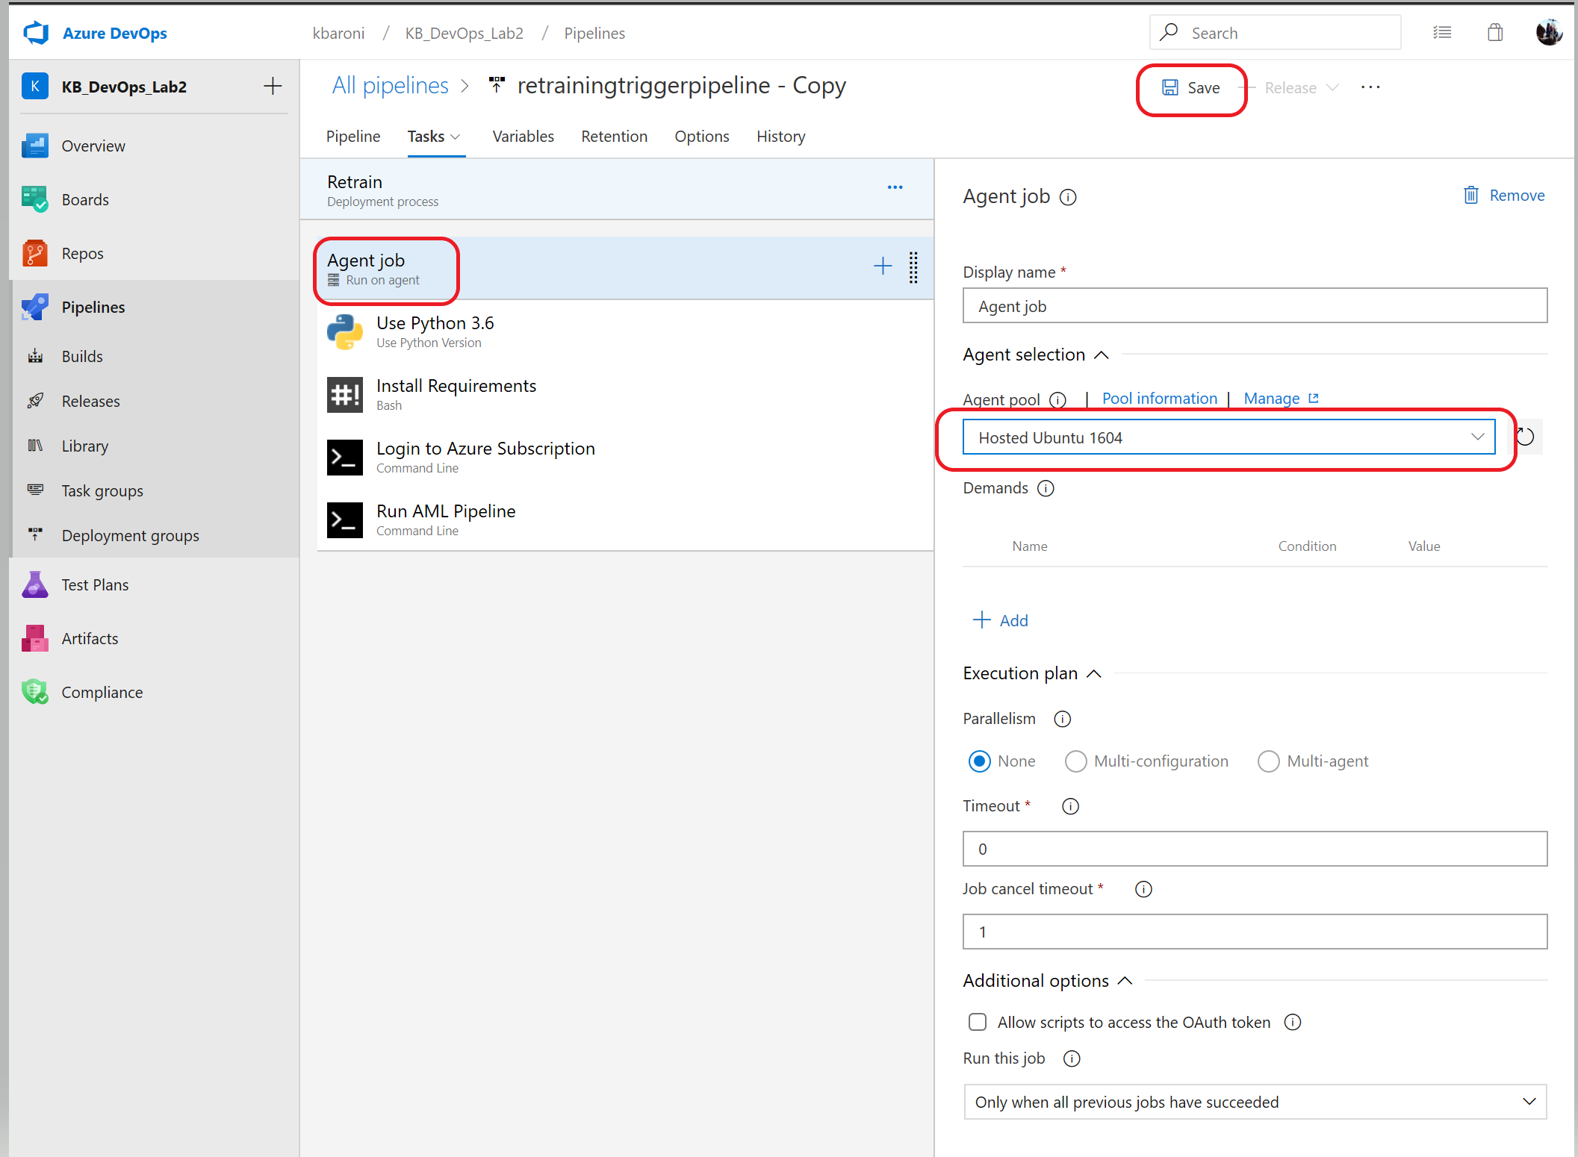

1. This pipeline needs access to the credentials and IDs that are stored in the variables group. Click on the **Variables** tab, then click on **Variable groups** and select **Link variable group**. Select the variable group created earlier, click on **Link**, and click on **Save** and then **OK**.

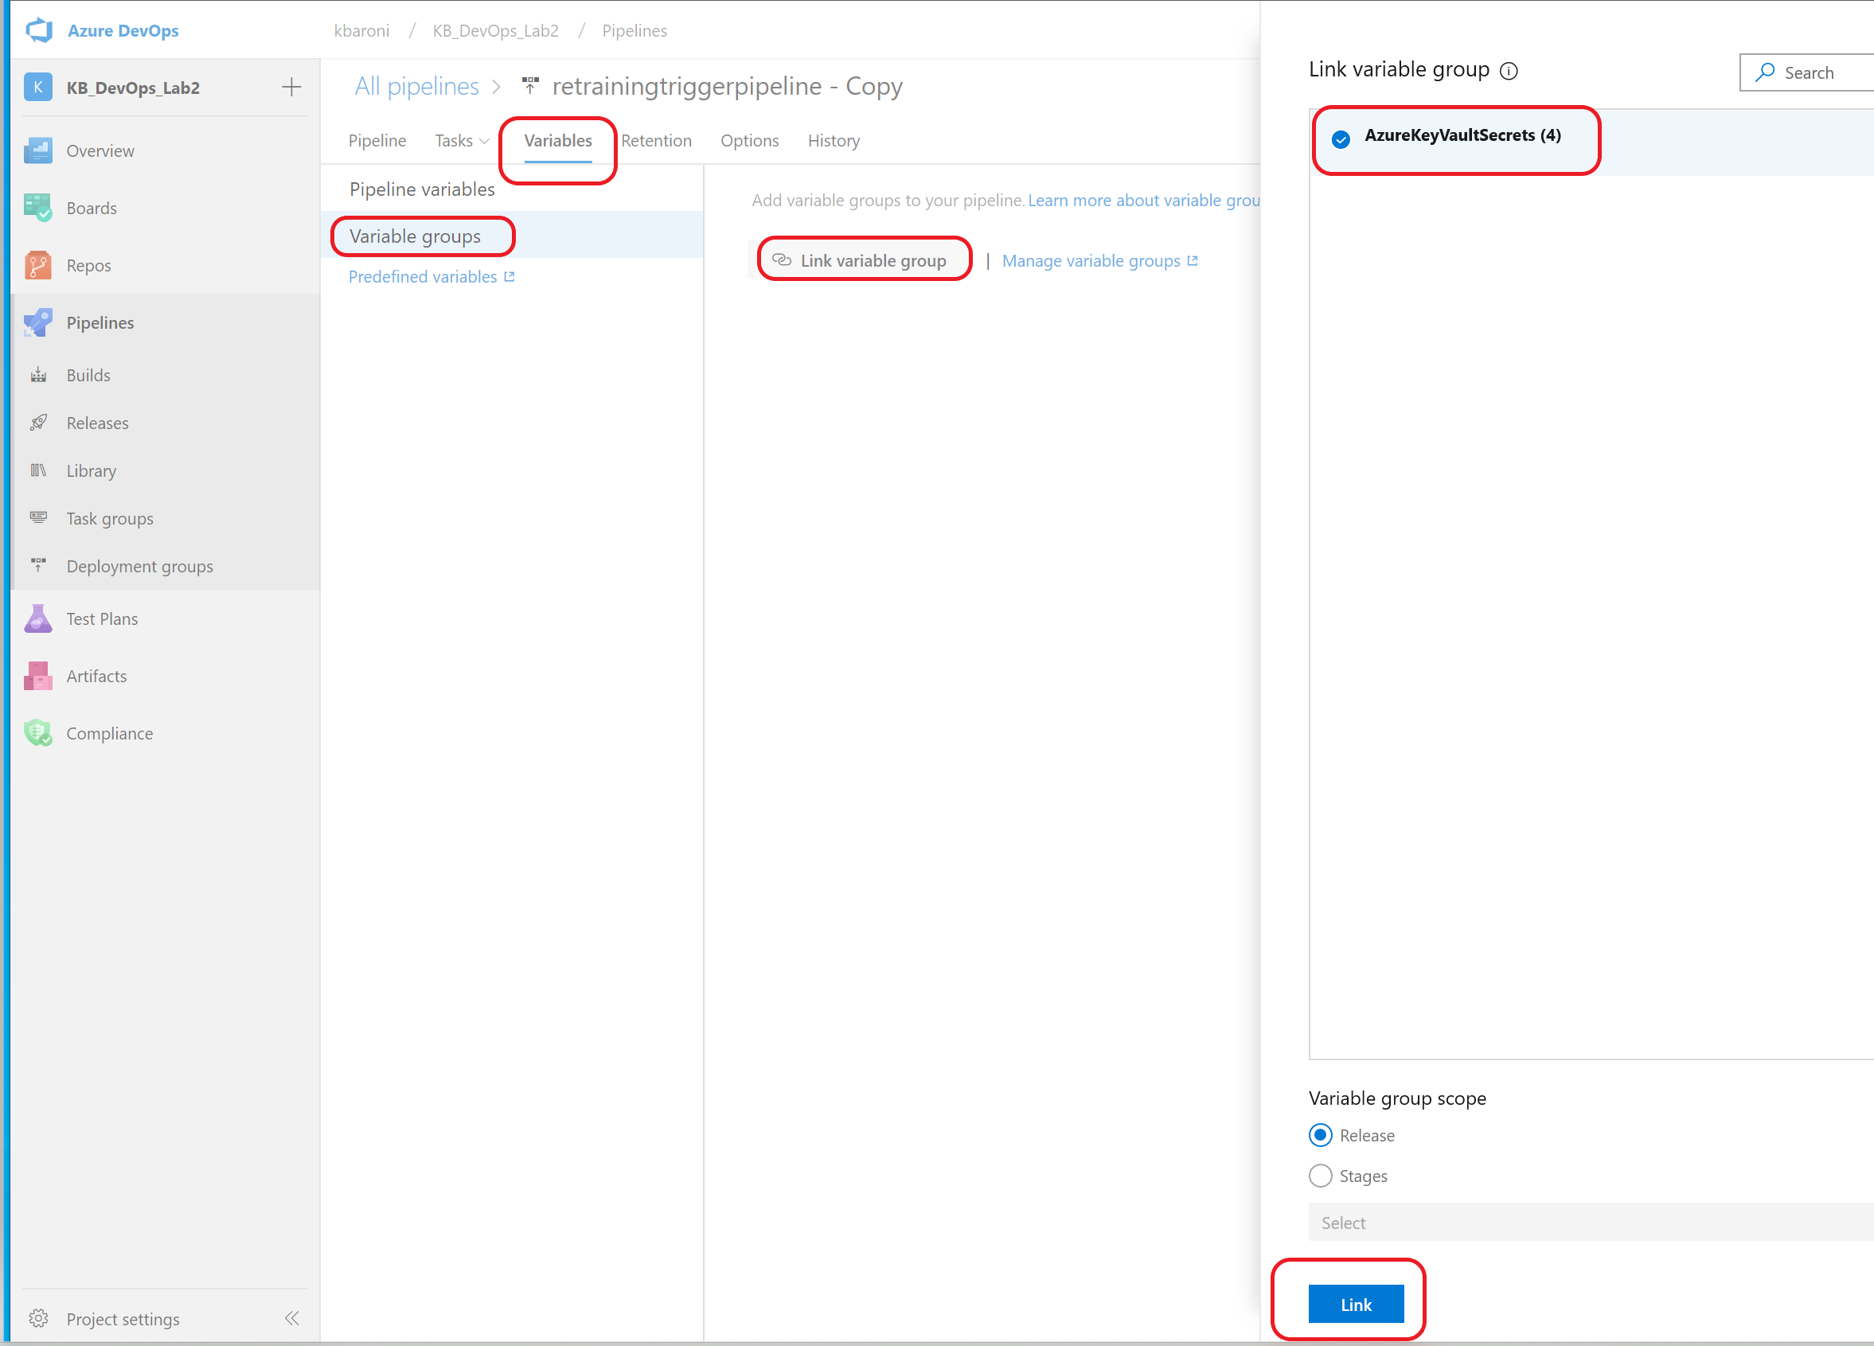

The next step is to create a trigger for the retraining pipeline; we want the retraining pipeline to execute every time the build pipeline completes successfully. To create this relationship, link the artifact from the build pipeline as a trigger for retraining pipeline.

9. Click on the **Pipeline** tab and select **Add an artifact** option under **Artifacts.**

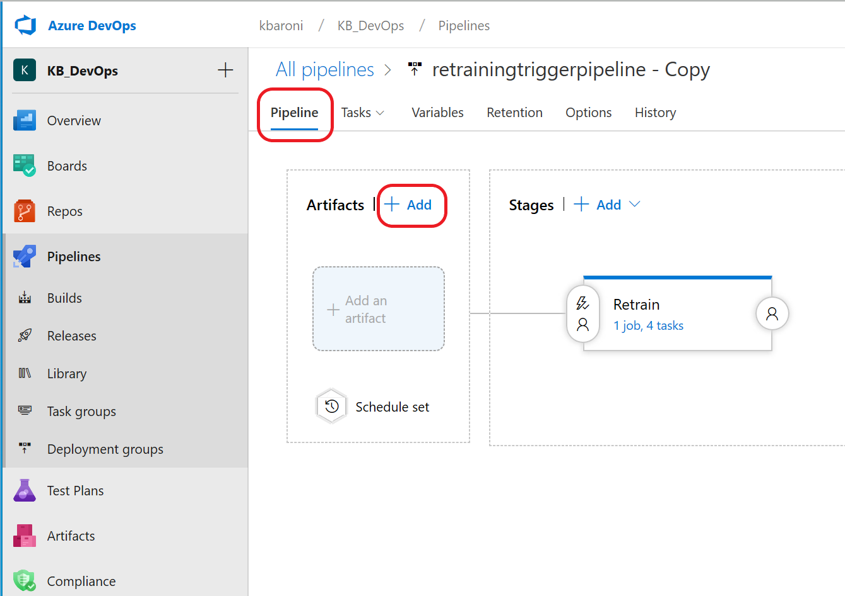

10. A window will pop open for adding an artifact. Select the following parameters:

Source type: select Build

Project: select the name of the project

Source: select the name of the build pipeline (it may also be the name of the project)

Default version: Latest

Source alias: replace the auto populated field with **DevOpsForAI.**

11. Click on **Add** and then **Save** the pipeline:

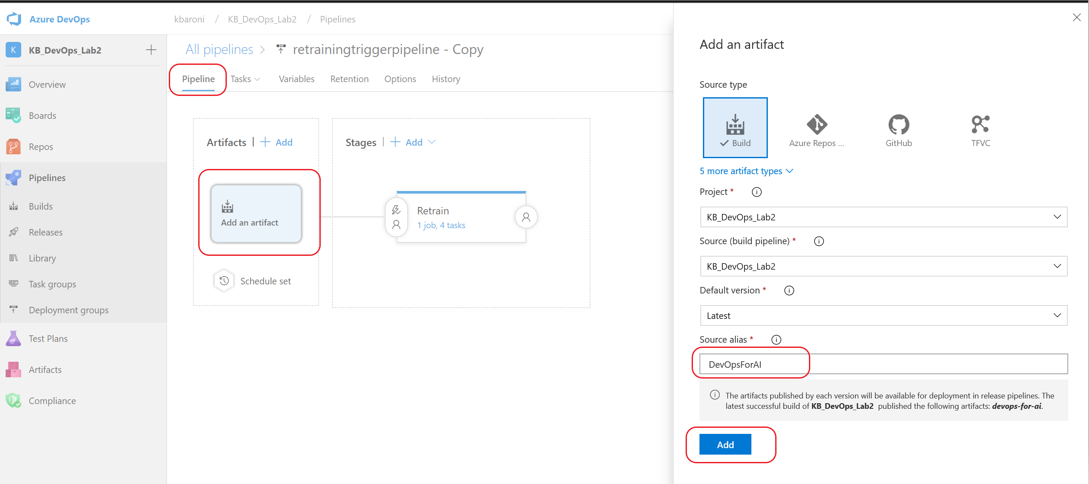

1. To trigger this pipeline every time a build is executed, enable the Continuous Deployment Trigger by clicking on the lightening sign, and sliding the bar for **Continuous Deployment** to **Enabled**. Click **Save** and then **OK.**

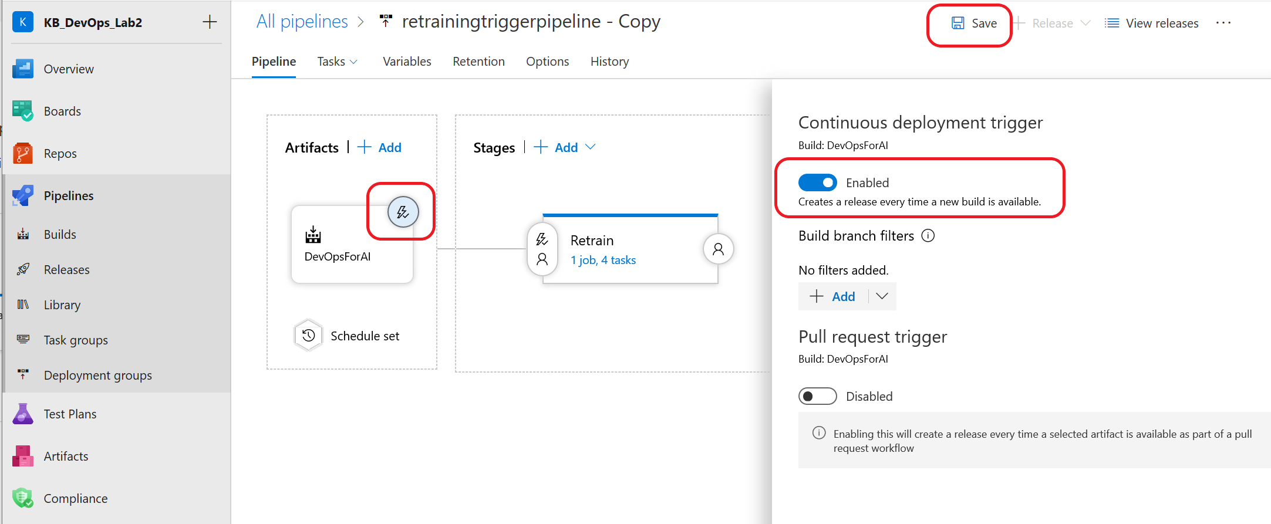

**Note:** Although we won’t be doing it as part of this lab, to schedule a pipeline you would click on **Schedule set.**

1. To verify the pipeline works as expected, initially you will manually trigger it. Navigate to the left pane and select **Releases.** Click on the retraining pipeline we just created and then click on **Create a release** as shown below**.**

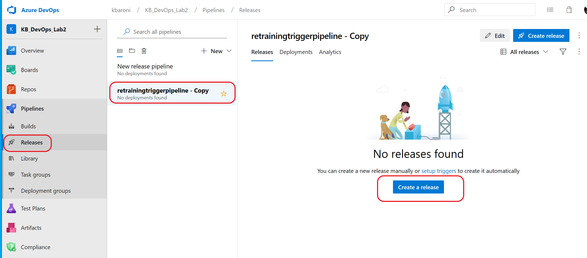

1. On the next screen, click **Create** to initiate a manual release.

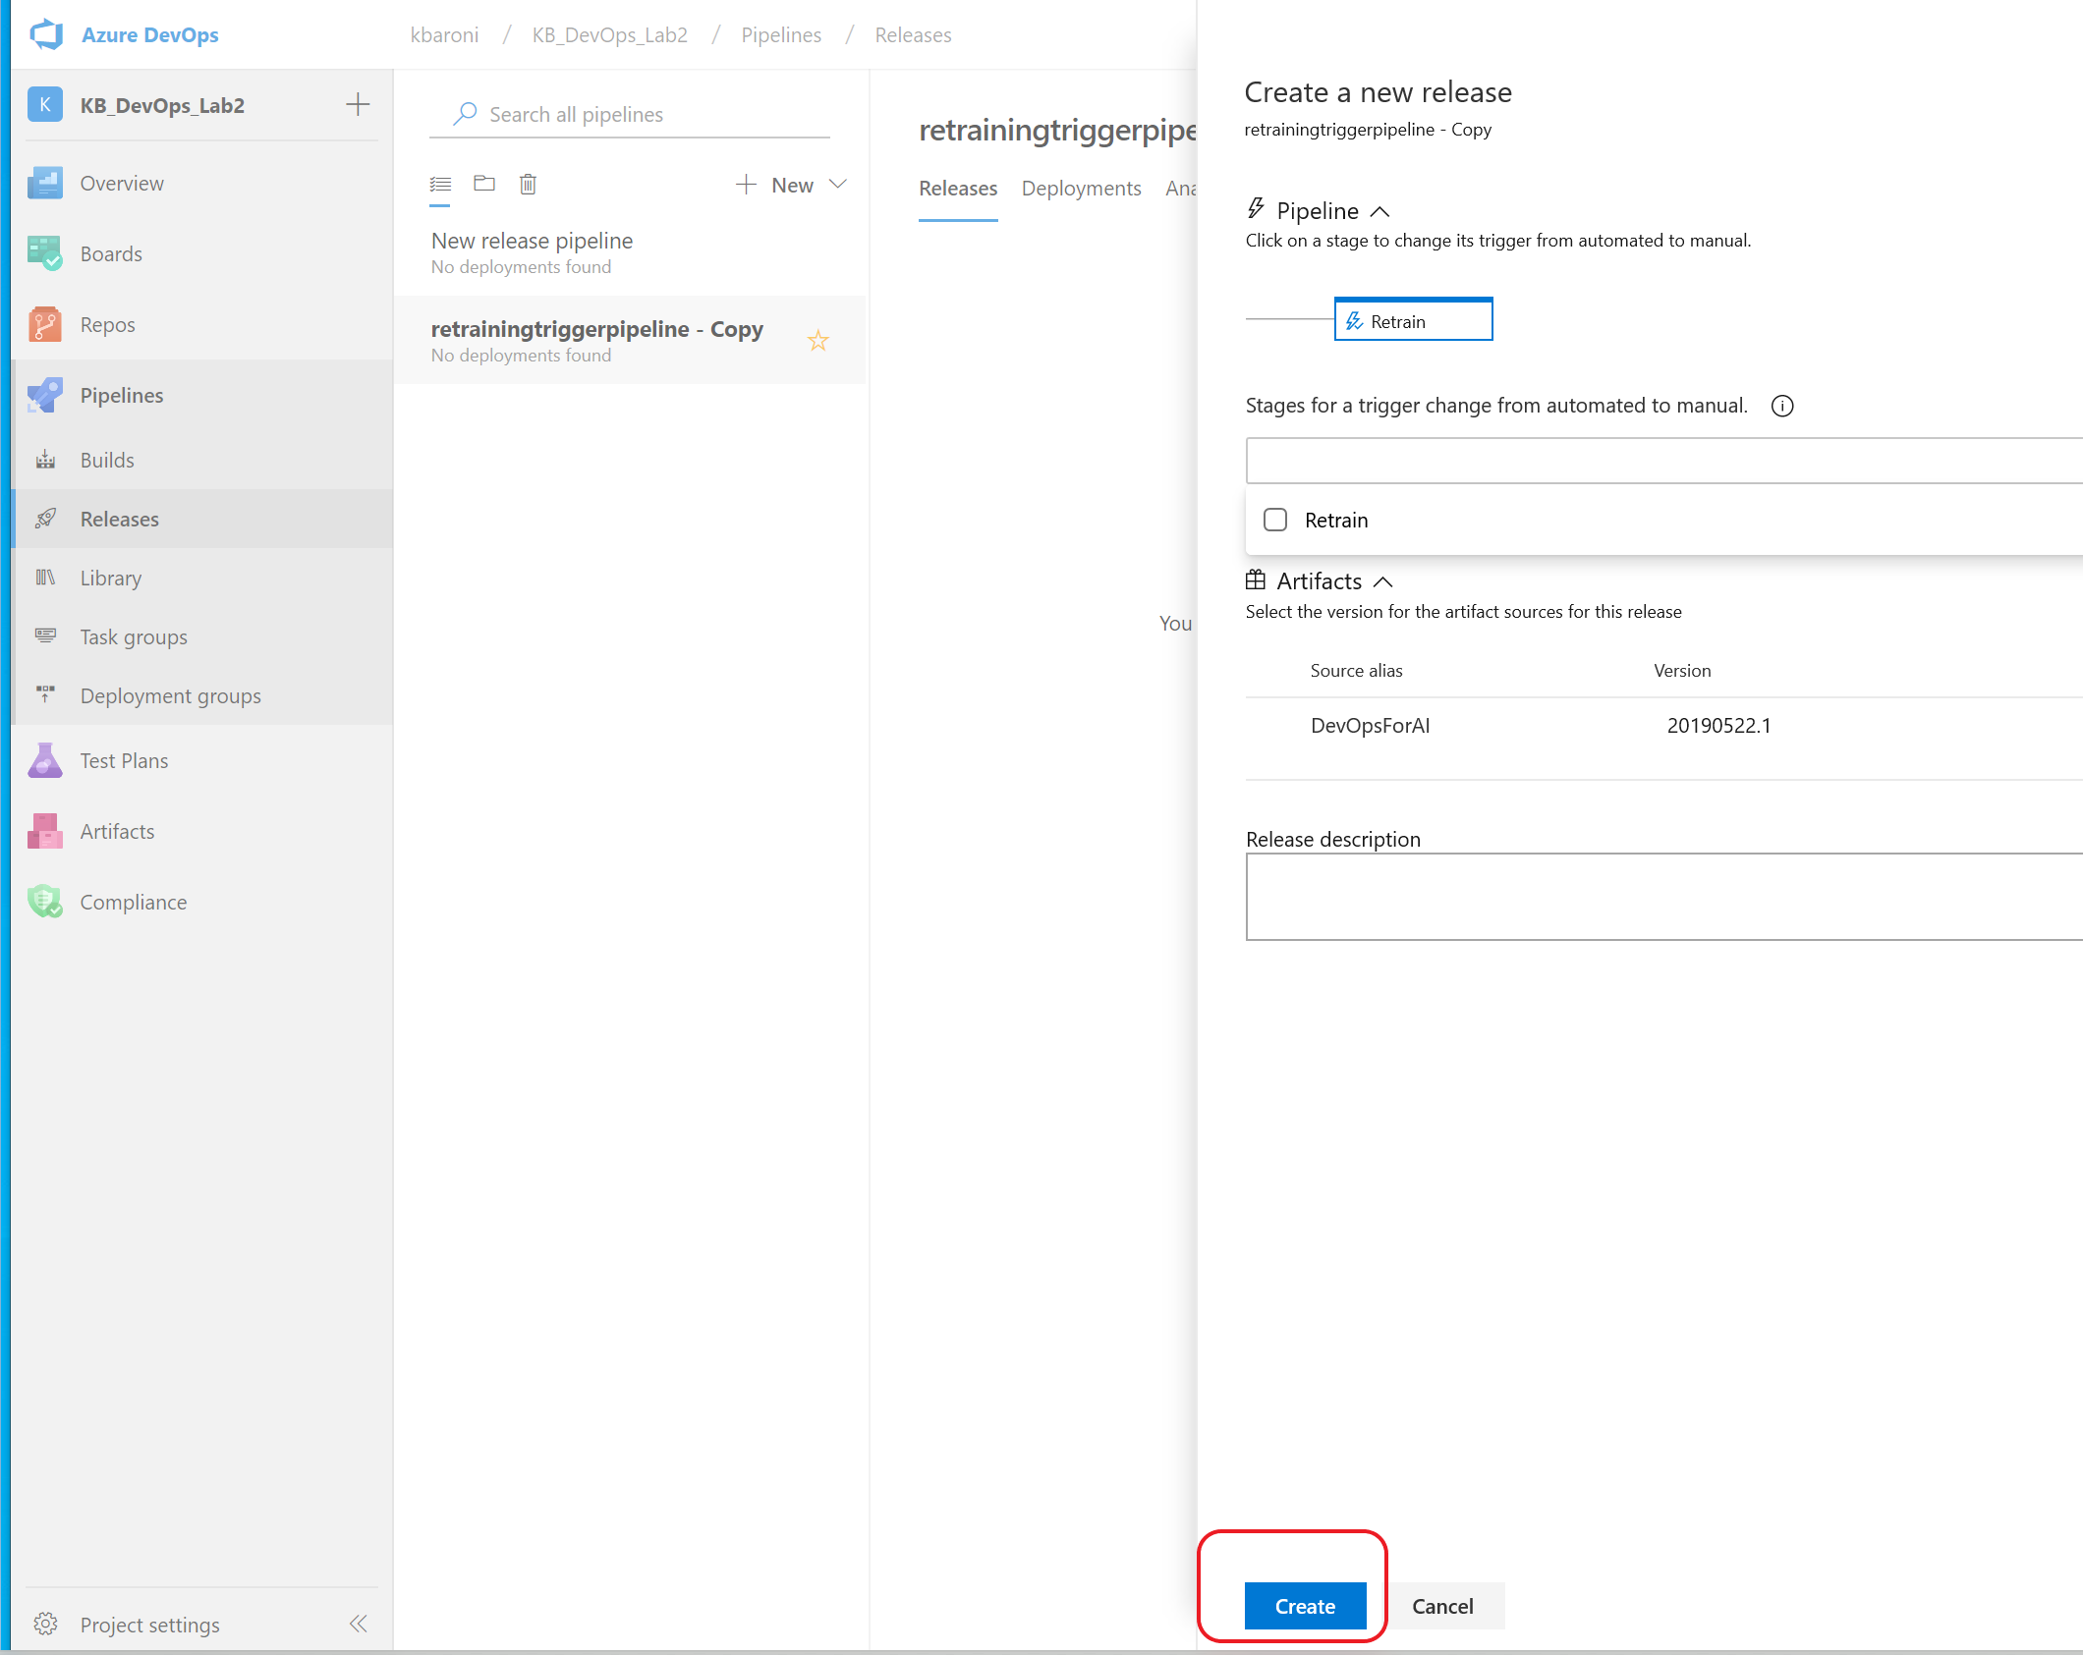

Notice in the image below the release has been queued. Your screen should look similar.

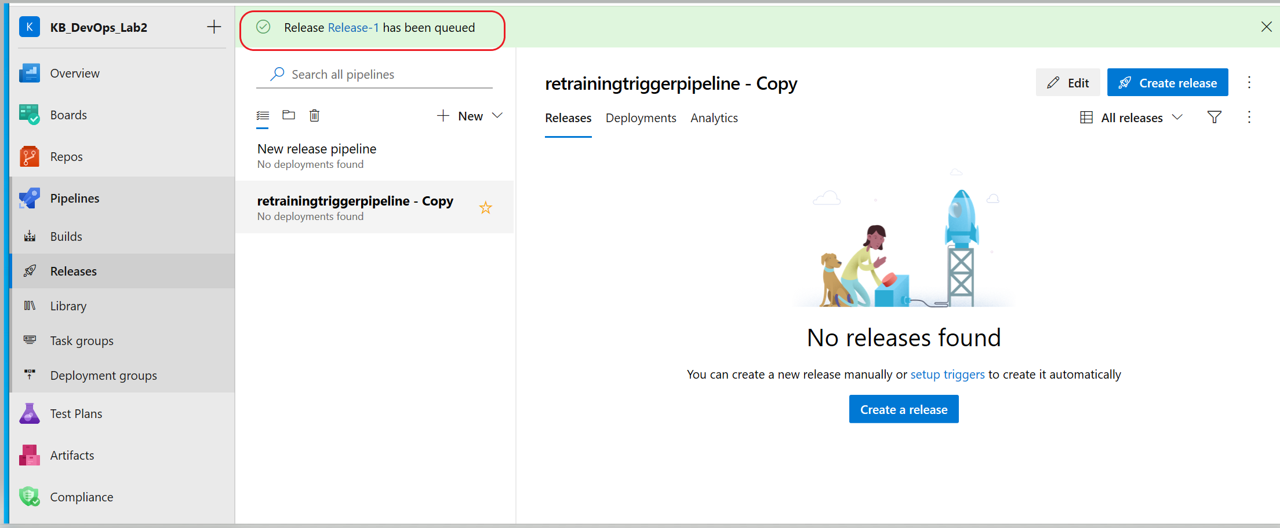

It will take a few minutes for the retraining pipeline to execute and when it is completed, it will show up under **Stages.** A successful execution will be highlighted in green and a failed execution will be highlighted in red. The following image shows a sccessful execution.

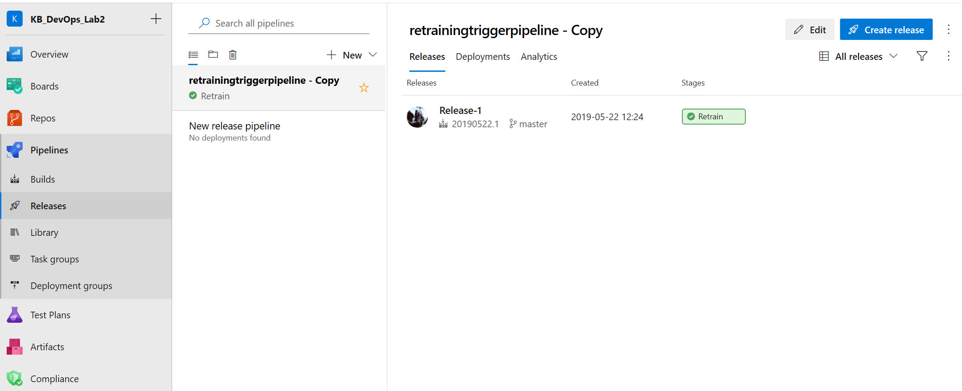

1. Examine some of the execution details by clicking into the green (or red) hyperlink **Retrain**. A window will pop up and you can review the steps and the execution time for each step. For additional details, click on the individual step to see the specific command and scripts that were executed.

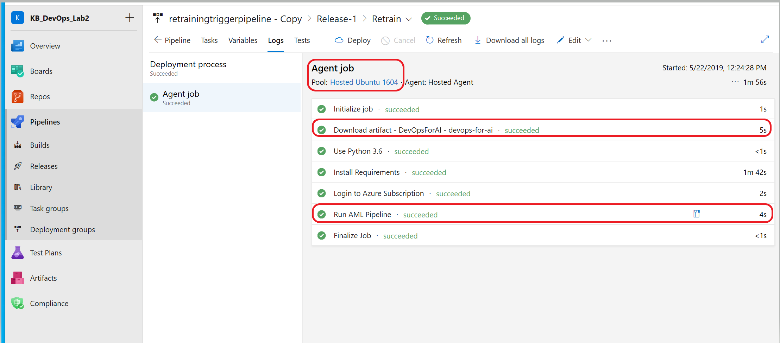

# Exercise 8: Setup the Deployment Pipeline

For the final pipeline – the deployment pipeline – you will also import a pre-defined pipeline. To successfully execute the deployment pipeline both of the previous pipelines will have had to been successfully executed.

To set up the deployment pipeline:

1. On the Azure DevOps project page, navigate to the left pane and select **Pipelines** -> **Releases** -> **New** and from the dropdown select **Import release pipeline**. When the next screen appears, browse to the ***release-pipelines*** folder and select ***releasedeployment.json***. Click **OK** as shown in the below image.

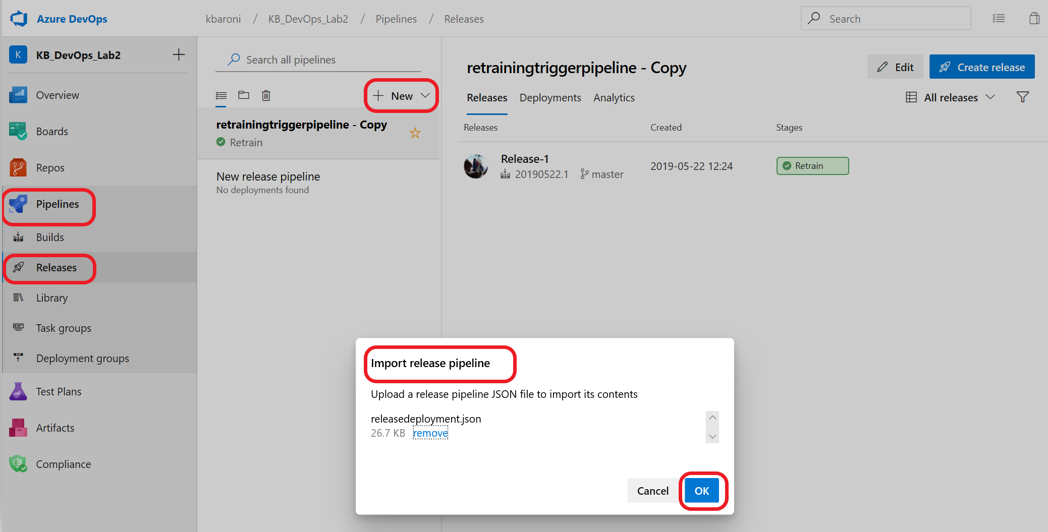

1. When the following screen appears, notice the deployment pipeline has two stages: **QA Environment** and **Prod Environment**. First, we will complete the settings for the QA Environment.

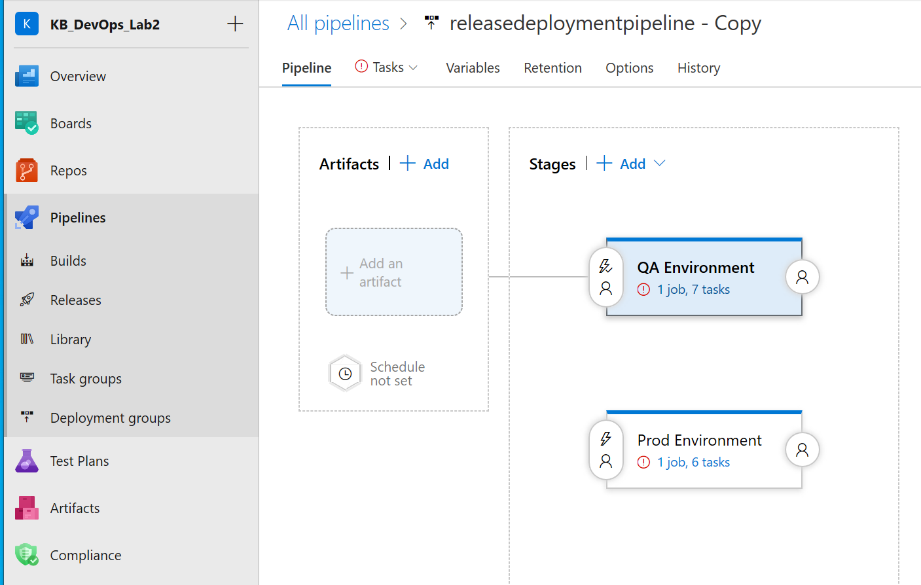

1. Click on the red error sign in the **QA Environment** stage to bring up a page similar to the one shown in the image below. Like the re-training pipeline, we need to set the agent pool. Click on **Agent job** and from the drop-down for **Agent selection**, select **Hosted Ubuntu 1604** to execute the pipeline run. Click the **Save** button and navigate back to the tab for **Pipeline**.

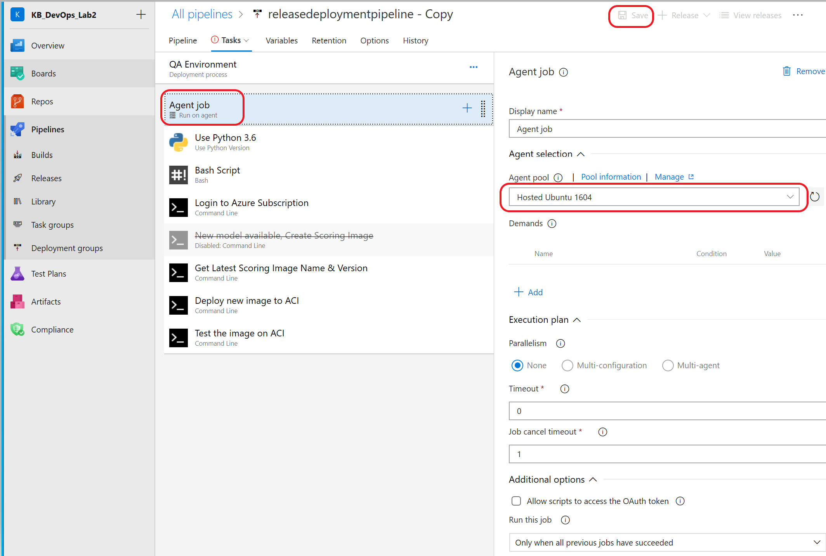

1. The agent pool for the **Prod environment** needs to also be set. Use the same setting as for the previous step as shown. Click on **Save** and **OK**.

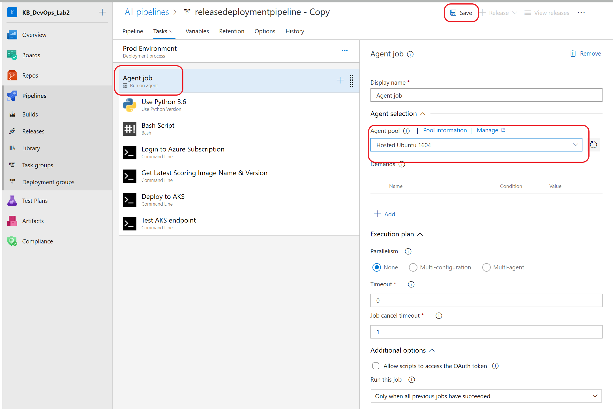

1. This pipeline also needs access to the credentials and IDs that are stored in the Variables group. Link the variable group into this pipeline. Click on the **variables** tab -> click on **Variable groups** -> select **Link variable group** -> select the variable group created for this project **AzureKeyVaultSecrets** -> click **Link.** Click **Save** and then **OK.**

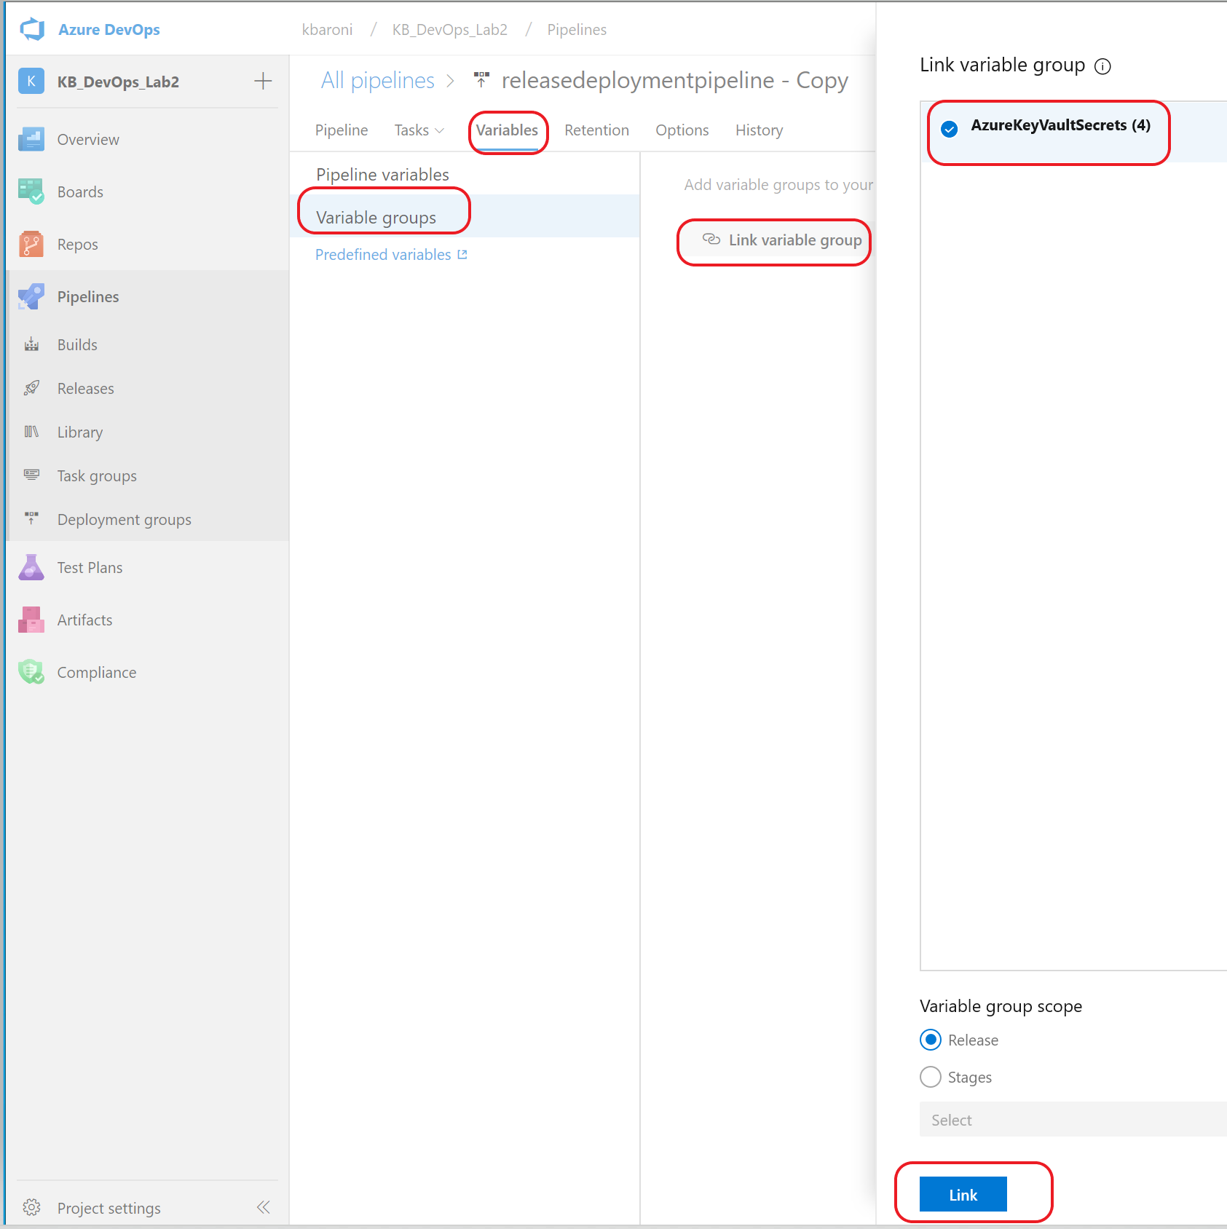

1. The QA pipeline will be triggered every time a new image gets published to the Azure container registry (ACR). ACR is an Azure managed docker registry service based on open source Docker Registry. To configure the pipeline to be triggered, two artifacts need to be added:

* Add an artifact for the Buildpipeline output because it contains the configuration and code files that are required for this pipeline.
* Add an artifact from the **ACR** to trigger the Build pipeline every time a new image gets published to the ACR as part of the retraining pipeline.

1. To add the **Build** pipeline output as an artifact, navigate back to the **Pipeline tab** -> click on **Add an Artifact** -> select the following.

Source type: Build

Project: Use the default value

Source: select the name of this project

Default version: defaults to **Latest**

Source alias: replace the auto-populated field with **DevOpsForAI**

Click **Add** and then **Save** and then **OK**.

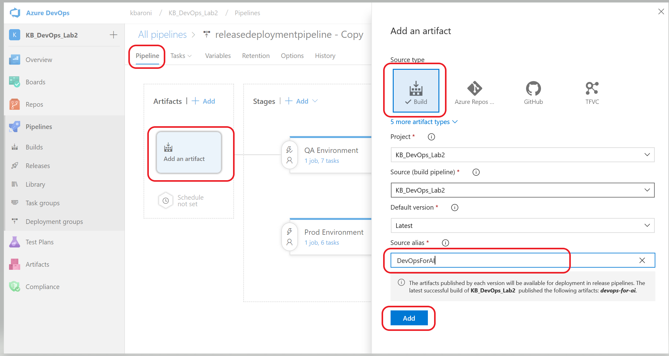

1. To add ACR as an artifact, follow similar steps as above to **Add an Artifact**. Select Azure Container Registry as a source type and provide the following settings:

Service connection: Select the service connection you created earlier in the lab.

Resource group: Select DevOps_AzureML_Demo (this is the default resource group name used for this lab).

Azure Container Registry: Select the one that is available in the drop down.

Repository: select diabetes-model-score repository

Default version: use the default Latest

Source alias: use the default generated name

Click **Add** and then **Save** as shown below**.**

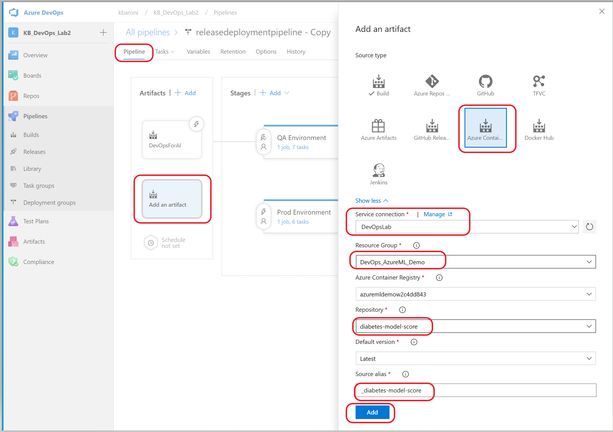

1. To implement Continuous Deployment, click on the lightening sign and slide the bar to **Enabled**. Click **Save** and **OK.**

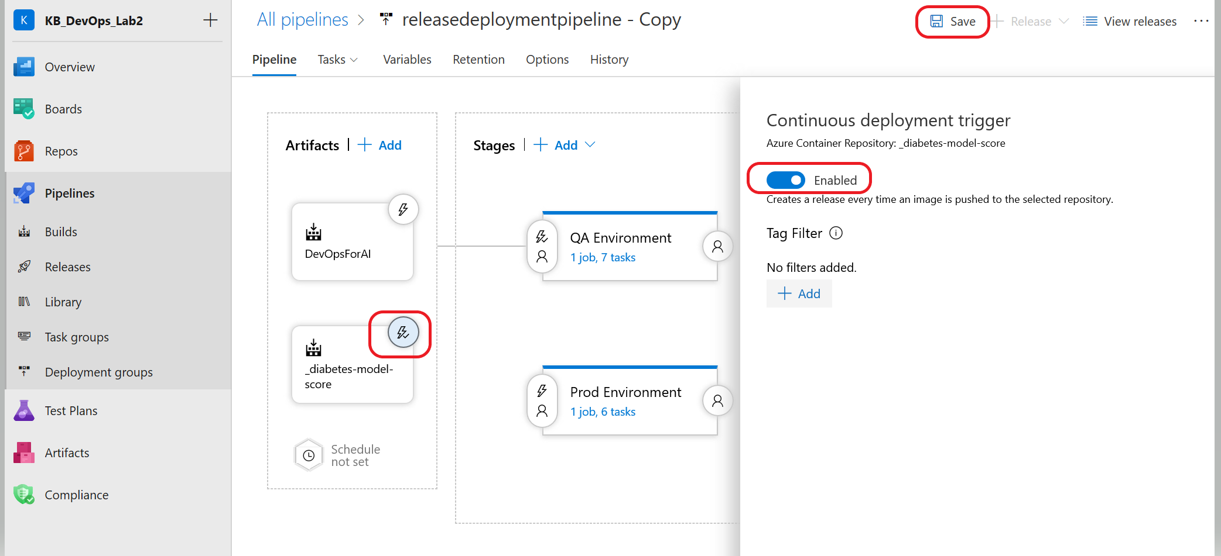

With these steps completed, the *QA environment* pipeline will be triggered each time a new image is available in ACR.

1. Typically, deployments to the **Prod environment** are not auto deployed. To ensure only a manual trigger is enabled for the Prod environment, click on the left side of the Prod environment Stage to bring up **Pre-deployment conditions** and ensure **Manual only** is selected as shown.

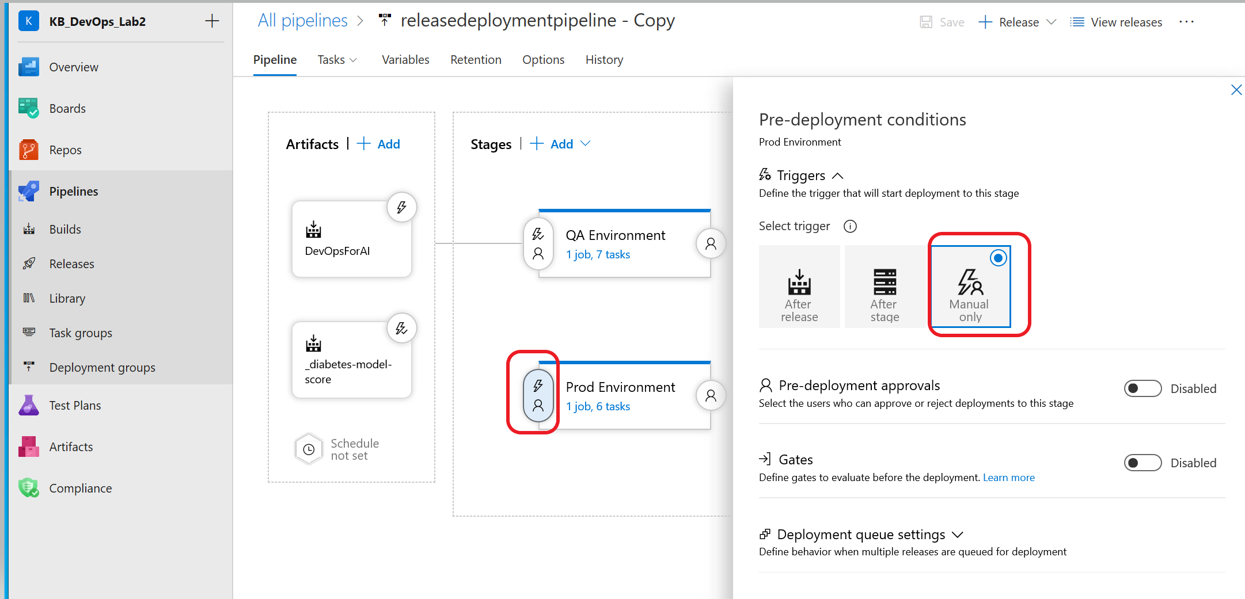

1. The release pipeline is now configured and ready to be deployed. To deploy the release pipeline, navigate to the **Releases** icon on the left pane. Highlight the *releasedeploymentpipeline* and select **Create a release**.

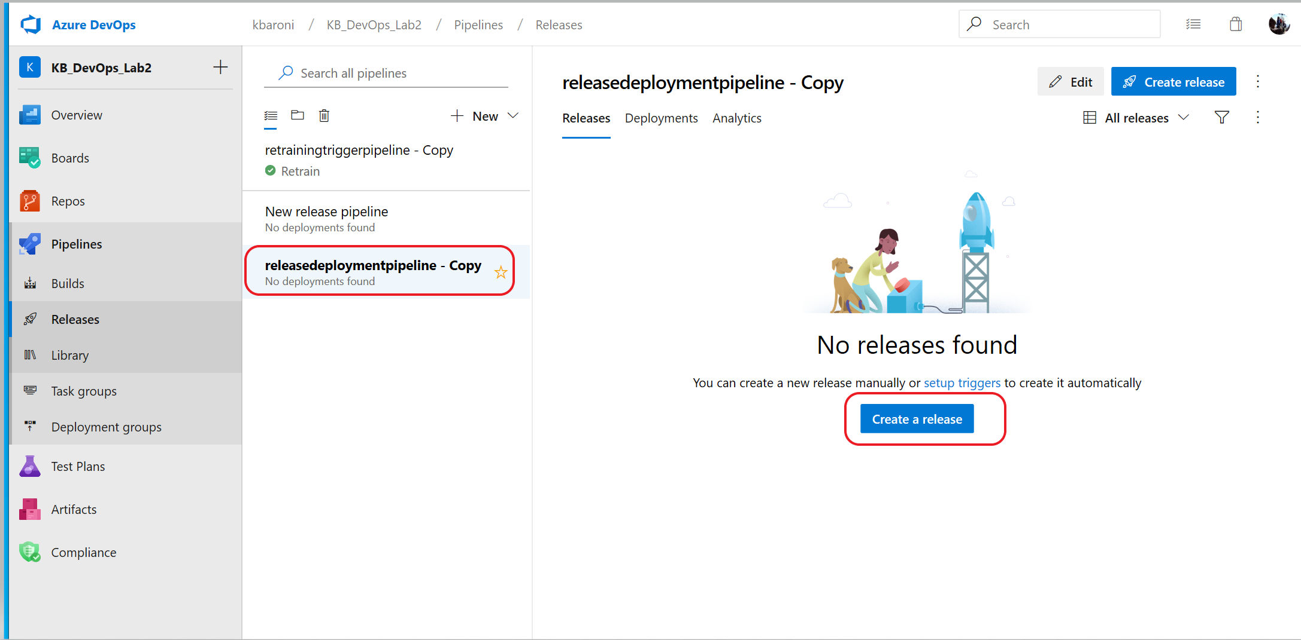

1. When the next screen appears, click on **Create** and the release will be queued as shown in the below image.

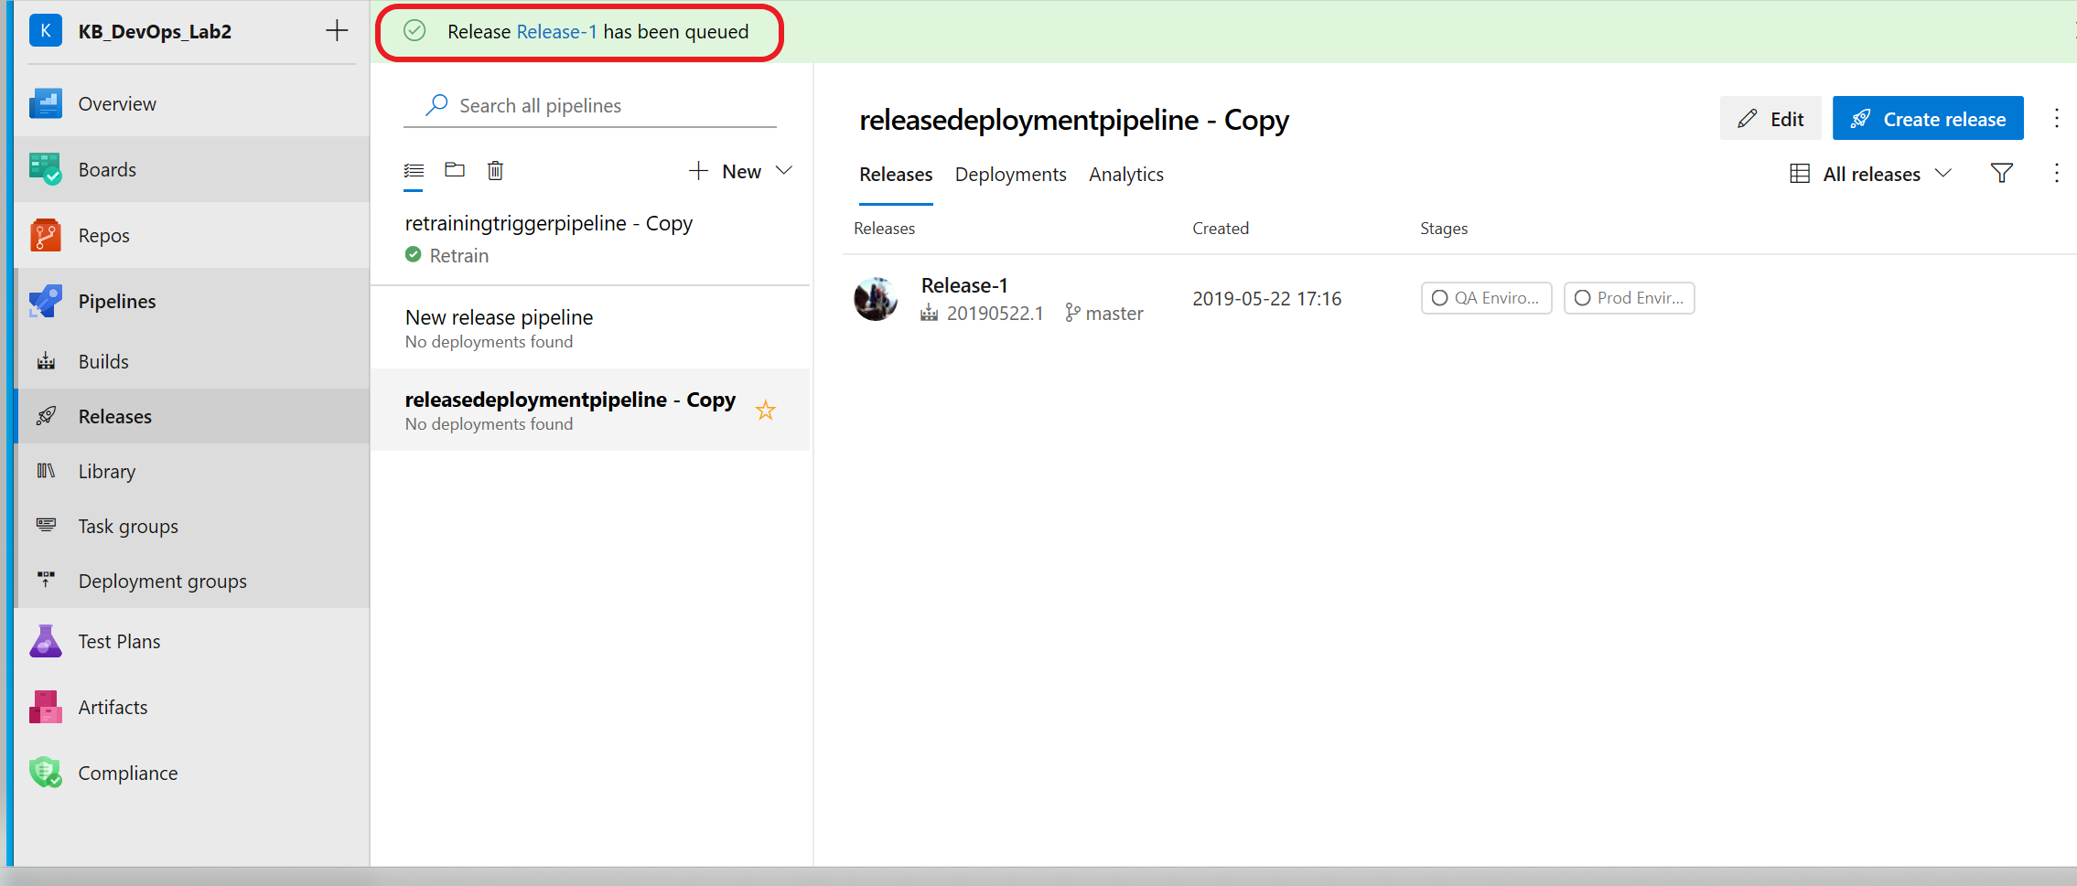

1. As the pipeline executes the box underneath **Stages** will change color to blue to indicate execution and will change to green or red when execution completes (you may need to refresh the browser to see the updated status).

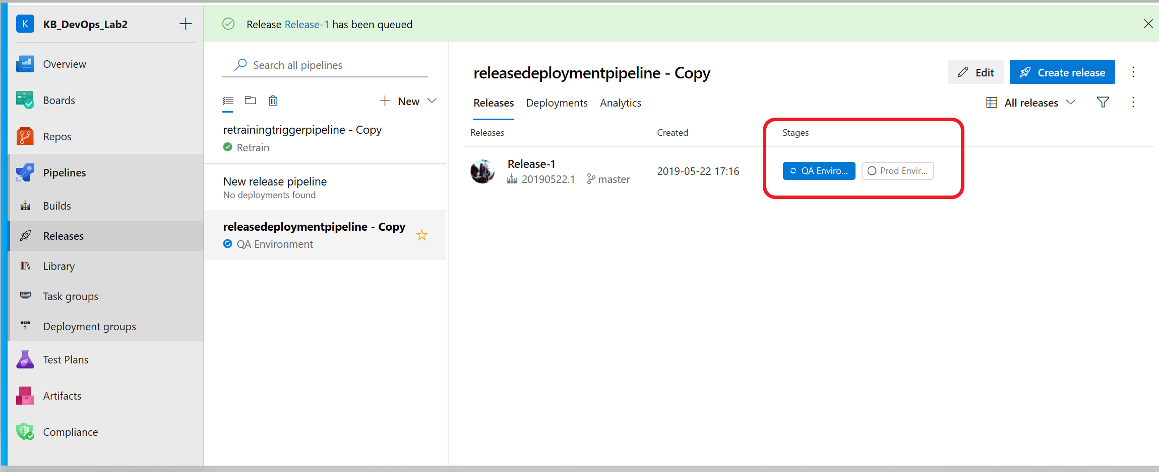

**Note:** It will take a few minutes for the QA environment release to execute.

1. To manually execute the **Prod environment** Stage, once the **QA Environment** stage has successfully completed, click on the button for Prod Environment:

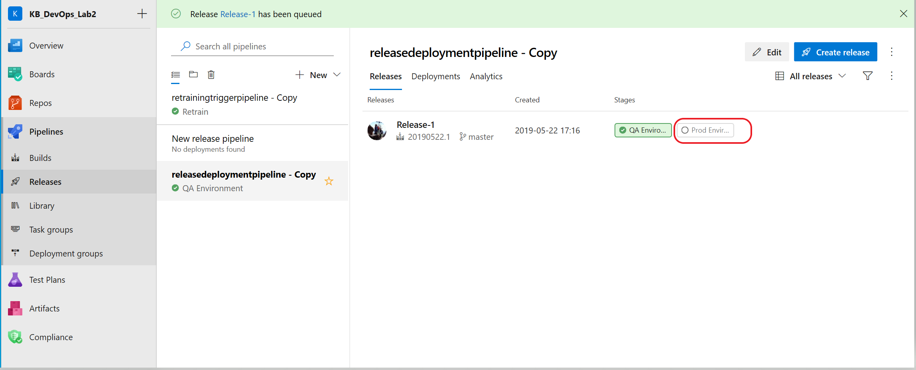

1. When a screen similar to the one below appears, click on **Deploy** and then click on **Deploy** again. This will queue the agent job and start execution.

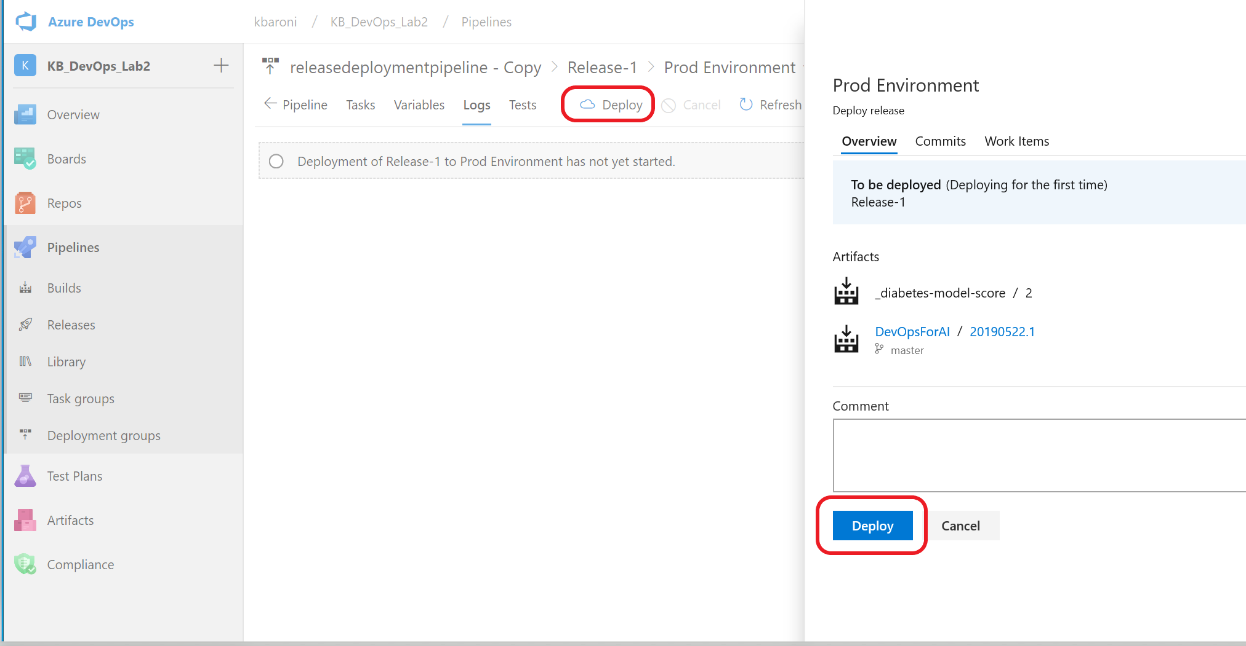

Execution of the Prod environment deployment can take 10-15 minutes if an Azure Kubernetes Service (AKS) needs to be provisioned. When the process completes, all the steps in the job will be highlighted in green (if successful) or red (if failure). Click into any of the steps to see execution details.

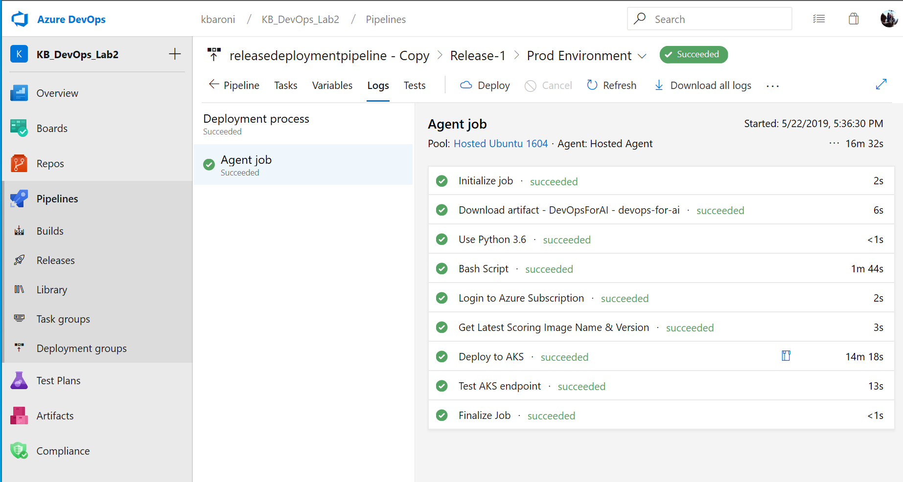

1. Return to the Releases page to view the execution status of both stages as shown below.

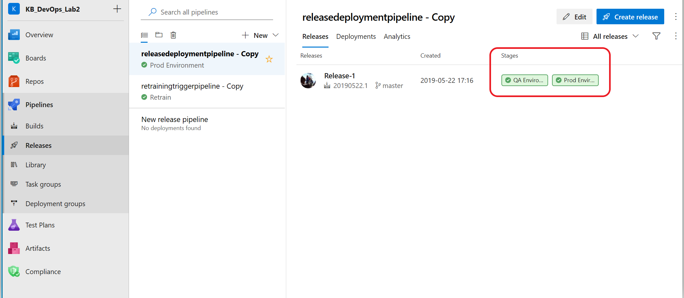

# Exercise 9 (optional): View resources from Azure Portal

View the artifacts and resources that have been provisioned through the Azure DevOps pipeline processing. The resource group used for provisioning is **DevOps_AzureML_Demo**. To view the resources:

1. Navigate to the azure portal <http://portal.azure.com>
2. On the left pane, click on Resource groups and scroll until you see **DevOps_AzureML_Demo.**
3. Click into the resource group and view the services that have been provisioned including **Container instances**, **Kubernetes**, **Key vault**, an **ACR**, etc.
4. Click into **Machine learning service workspace** and scroll through to see all the artifacts that have been created including an experiment, the training pipeline, the compute platforms, and information about the deployment assets.

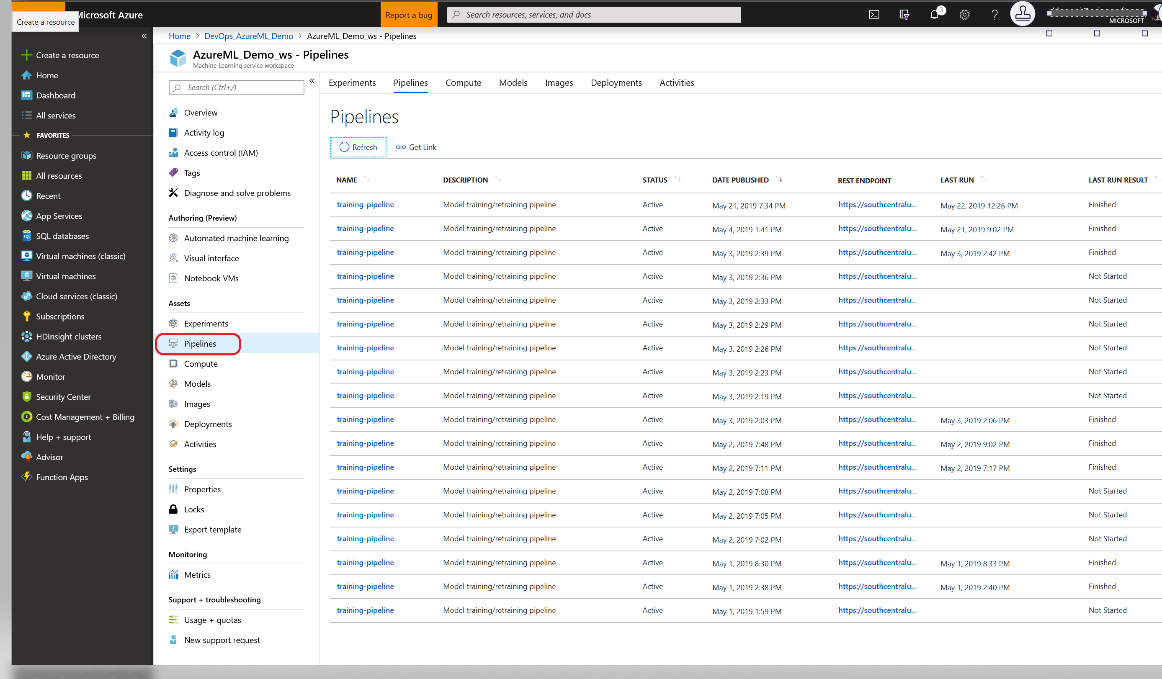

*Congratulations! You have completed the lab!*